Digital Thermometer
# Source: AI Source: Provided by: [Data Path: Persons Table -> ID Column: 1, Name_En Column: Motasem Essam] -> From: [ChatGPT] on [7/17/2026]
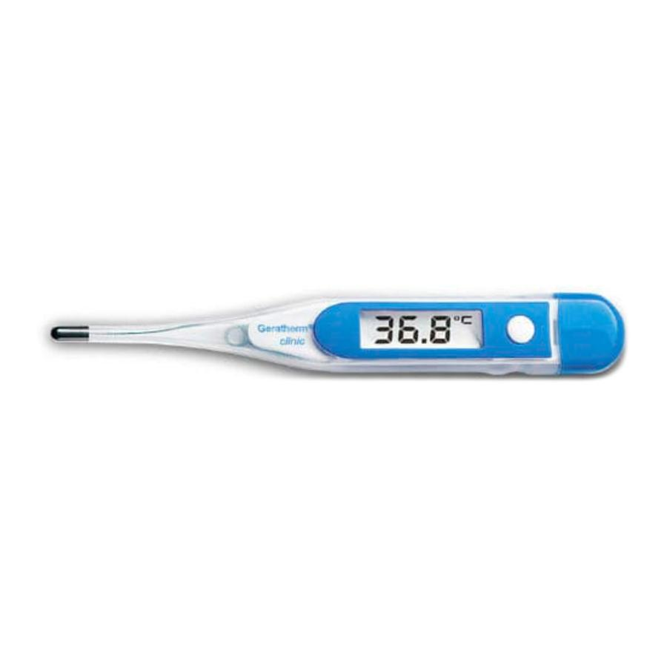
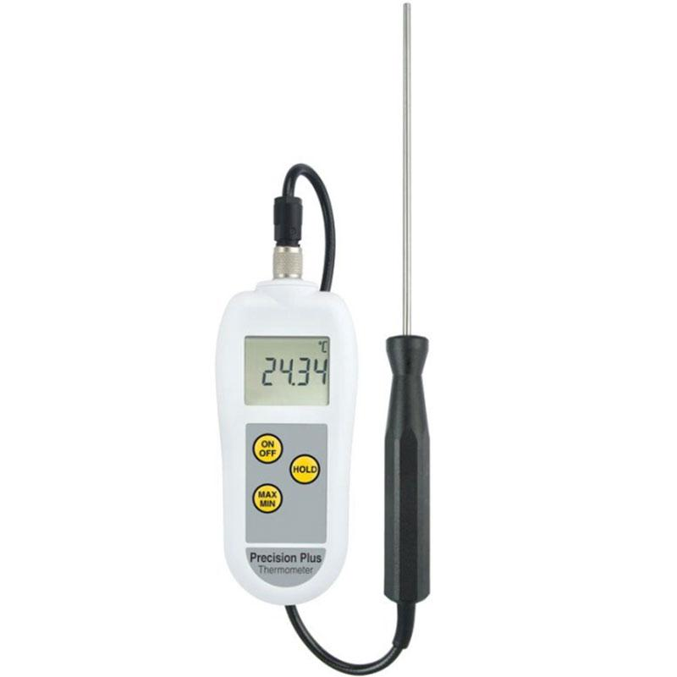
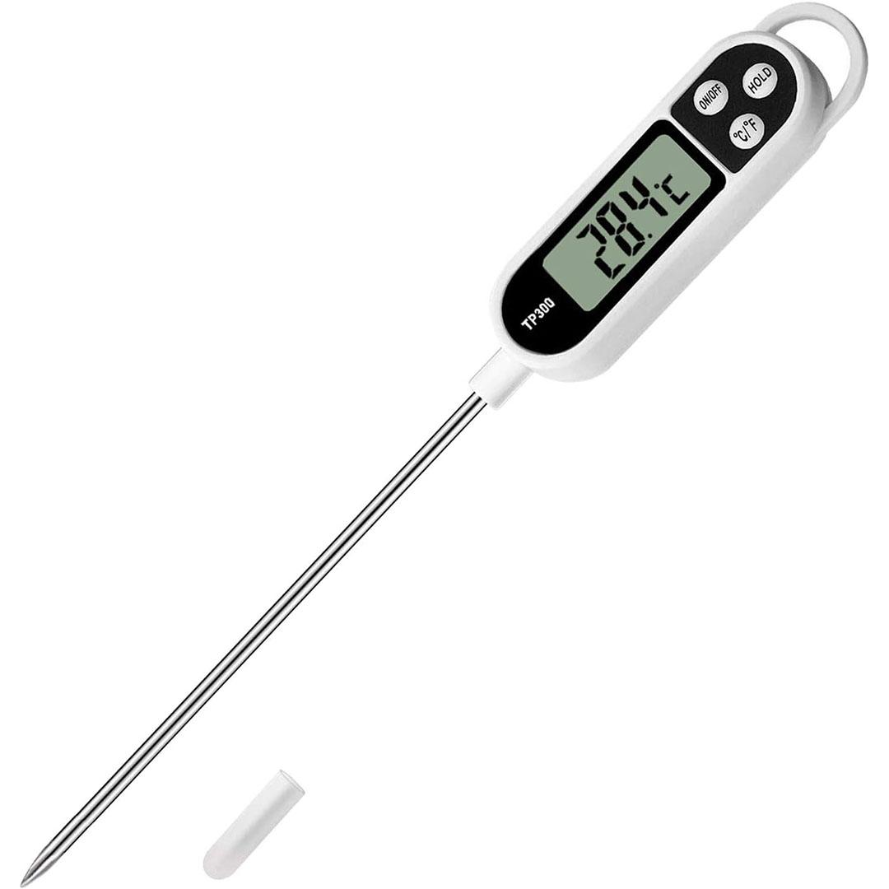
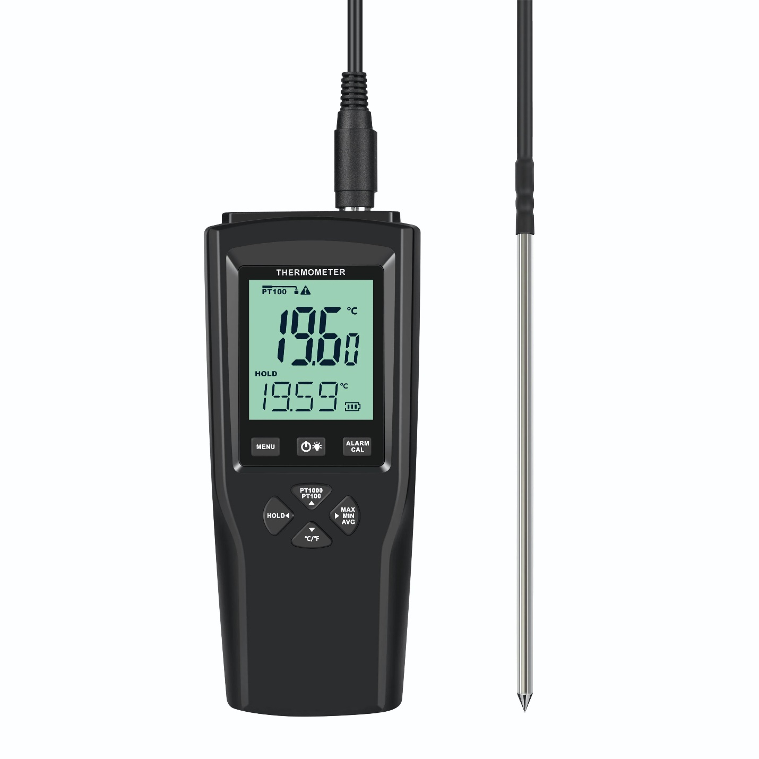
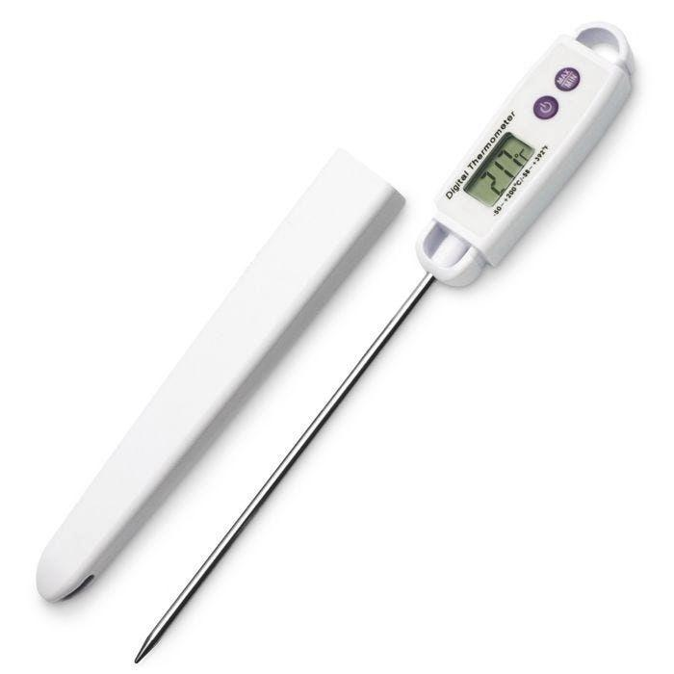
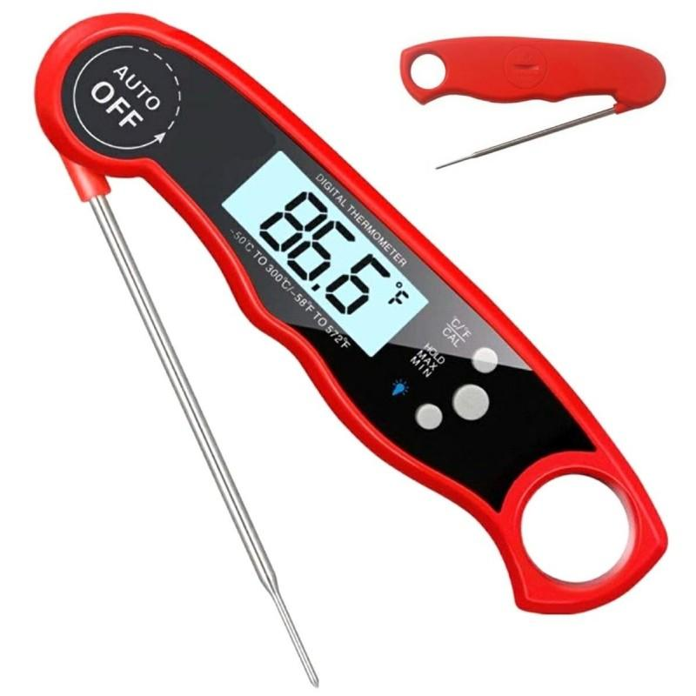
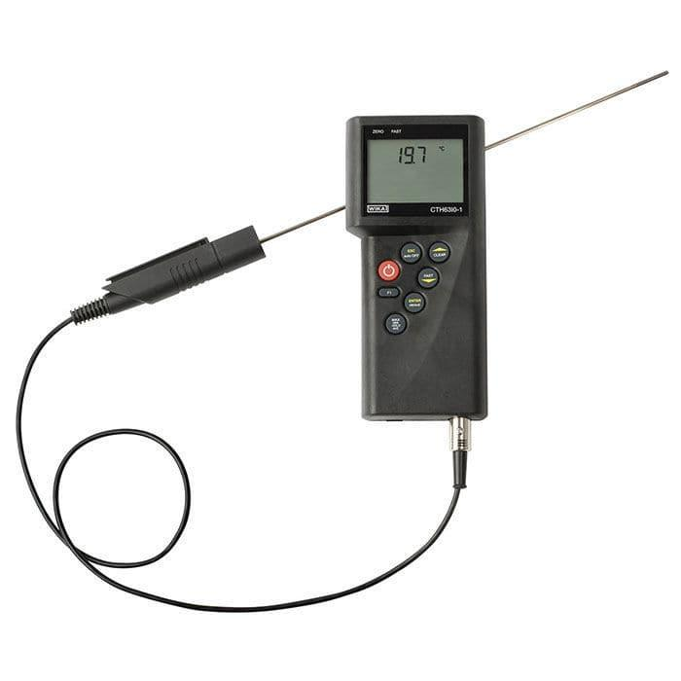
A Digital Thermometer is an electronic temperature-measuring instrument that uses a temperature sensor and electronic circuitry to measure temperature and display the result on a digital screen. It has become the most common thermometer for medical, laboratory, industrial, food, and household applications because it is fast, accurate, easy to read, and free from toxic substances such as mercury.

Definition
# Source: AI Source: Provided by: [Data Path: Persons Table -> ID Column: 1, Name_En Column: Motasem Essam] -> From: [ChatGPT] on [7/17/2026]
A Digital Thermometer is an electronic instrument that measures temperature using a sensor and displays the measured value digitally.

Purpose
# Source: AI Source: Provided by: [Data Path: Persons Table -> ID Column: 1, Name_En Column: Motasem Essam] -> From: [ChatGPT] on [7/17/2026]
A digital thermometer is used to:
- Measure body temperature.
- Measure liquid temperature.
- Measure air temperature.
- Measure food temperature.
- Monitor laboratory experiments.
- Measure industrial process temperatures.
- Verify storage temperatures.

Principle of Operation
# Source: AI Source: Provided by: [Data Path: Persons Table -> ID Column: 1, Name_En Column: Motasem Essam] -> From: [ChatGPT] on [7/17/2026]
A digital thermometer converts temperature into an electrical signal using a sensor.
The sensor's electrical properties change with temperature. Internal electronics process this signal and display the measured temperature on an LCD or LED screen.
Common sensing technologies include:
- Thermistor
- Resistance Temperature Detector (RTD)
- Thermocouple
- Semiconductor temperature sensor

Main Components
# Source: AI Source: Provided by: [Data Path: Persons Table -> ID Column: 1, Name_En Column: Motasem Essam] -> From: [ChatGPT] on [7/17/2026]
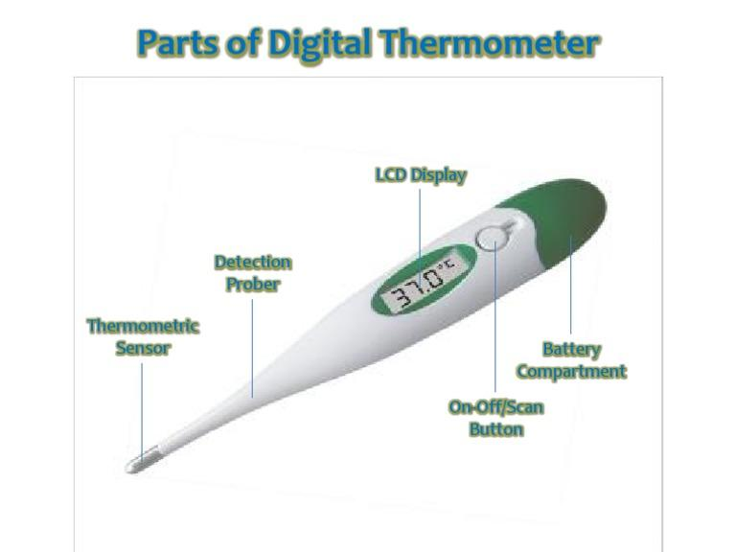
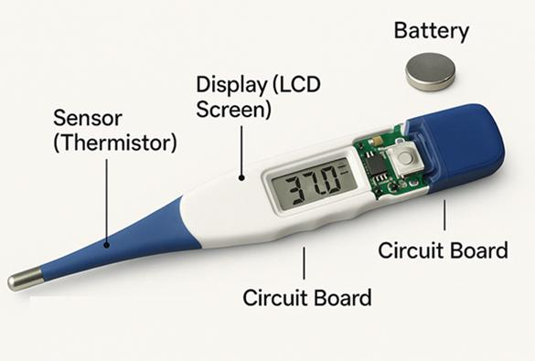
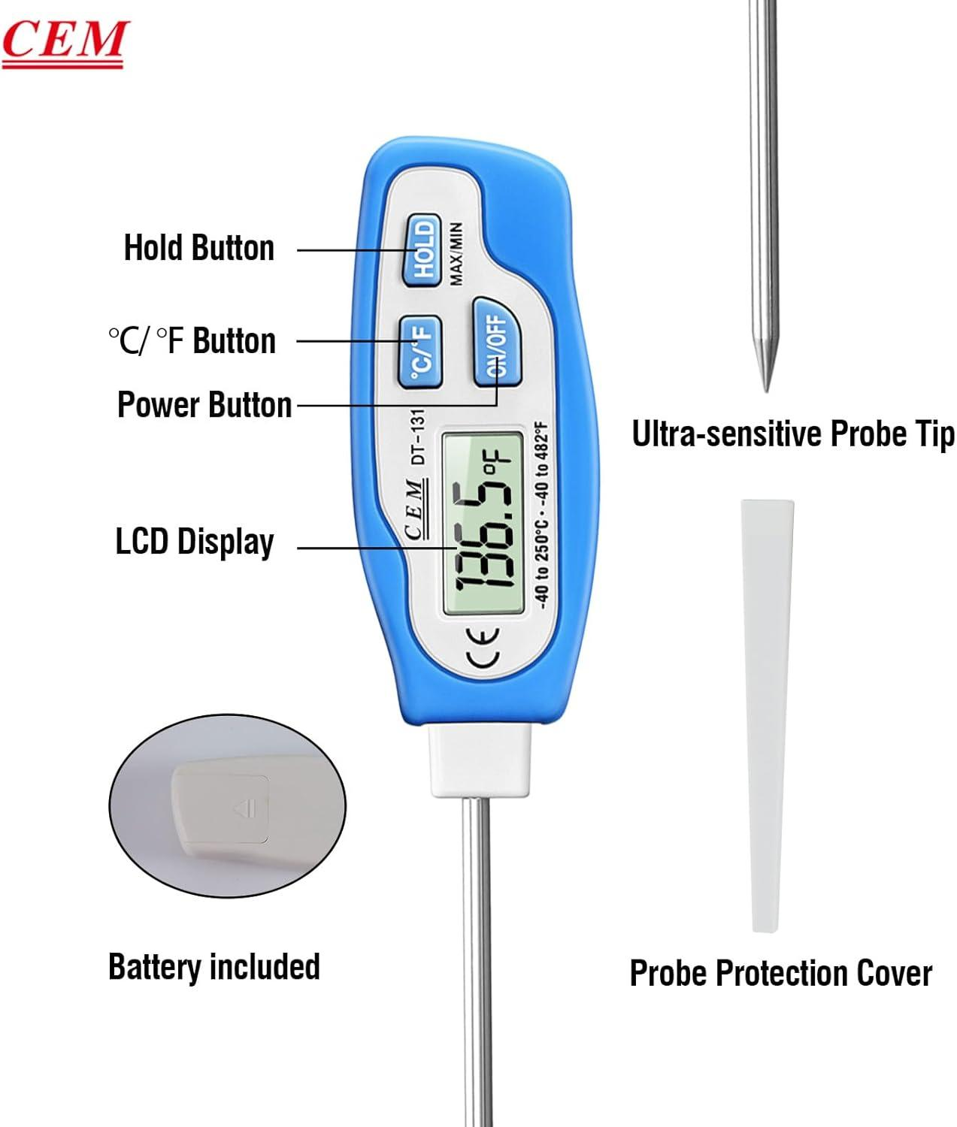
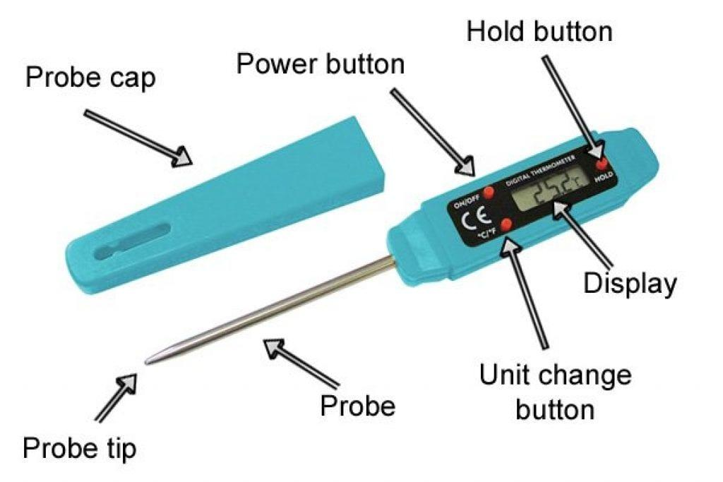
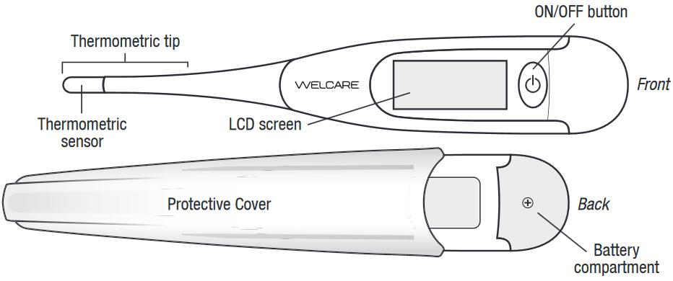
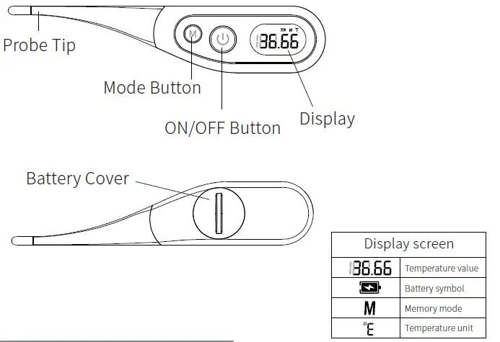
A typical digital thermometer consists of:
- Temperature sensor (probe)
- Electronic circuit
- Digital display (LCD/LED)
- Power source (battery)
- Control button(s)
- Protective housing

Types of Digital Thermometers

1. Clinical Digital Thermometer
# Source: AI Source: Provided by: [Data Path: Persons Table -> ID Column: 1, Name_En Column: Motasem Essam] -> From: [ChatGPT] on [7/17/2026]
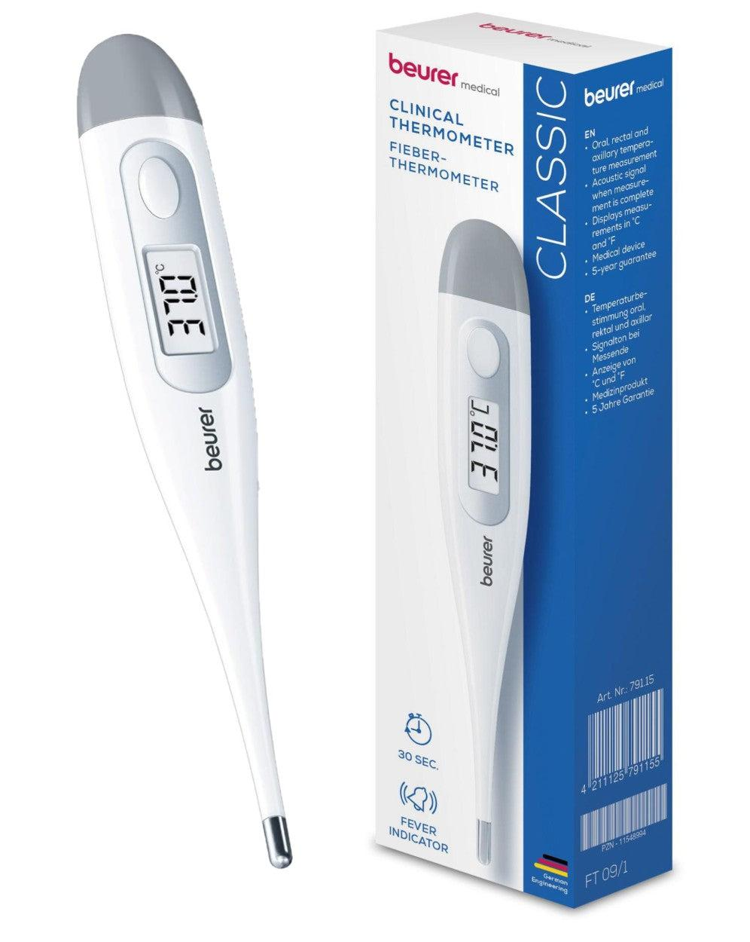
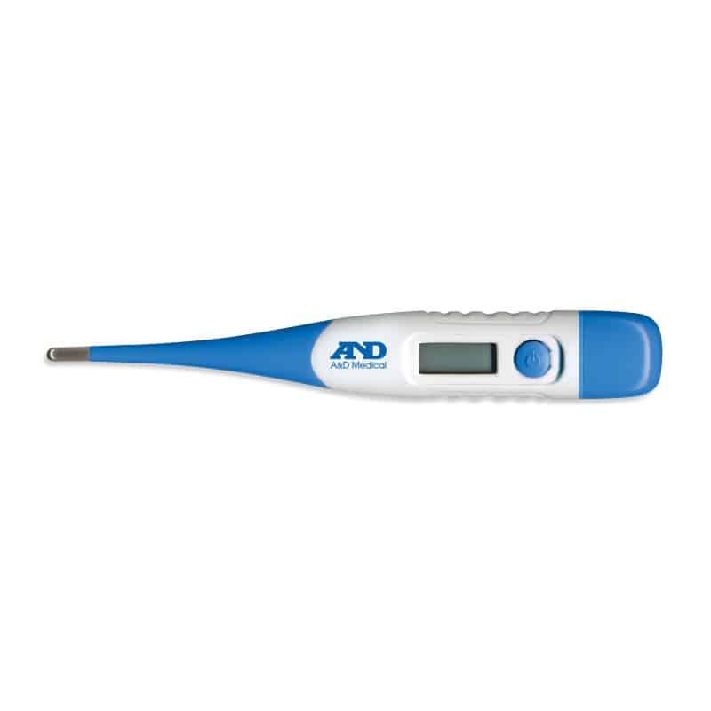
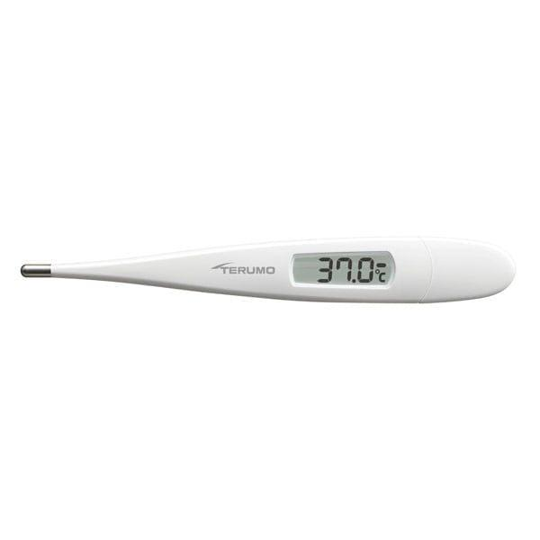
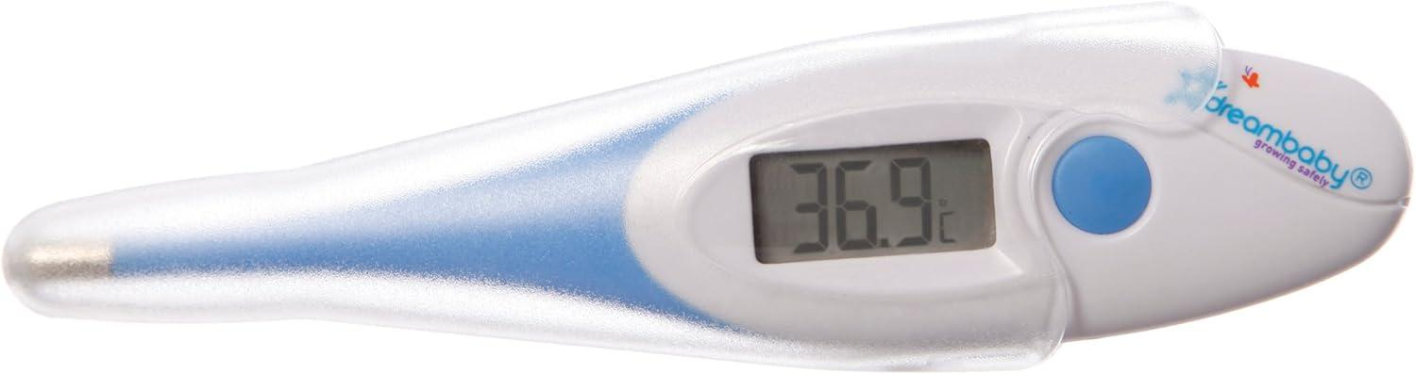
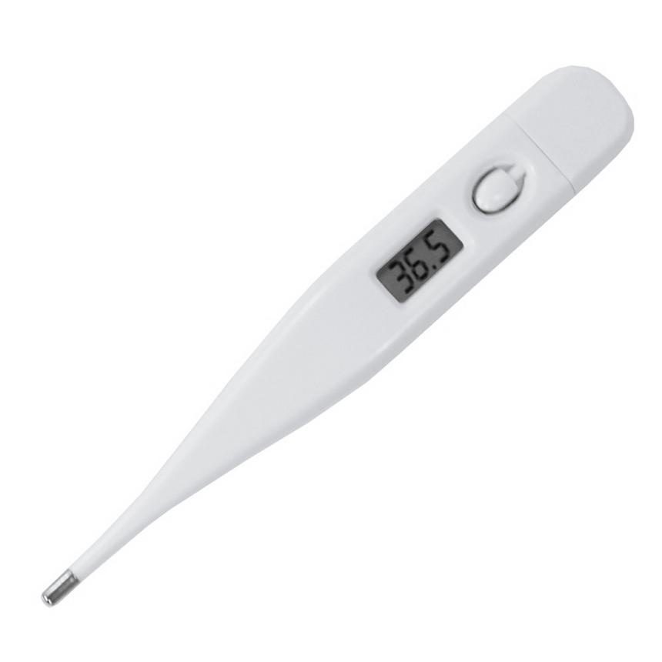
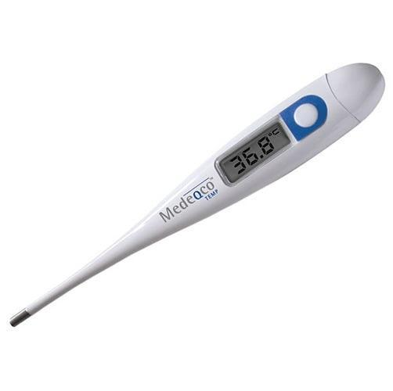
Description
Designed for measuring human body temperature.
Features
- Small probe
- Fast readings
- Audible completion signal
Applications
- Hospitals
- Clinics
- Home healthcare

2. Laboratory Digital Thermometer
# Source: AI Source: Provided by: [Data Path: Persons Table -> ID Column: 1, Name_En Column: Motasem Essam] -> From: [ChatGPT] on [7/17/2026]

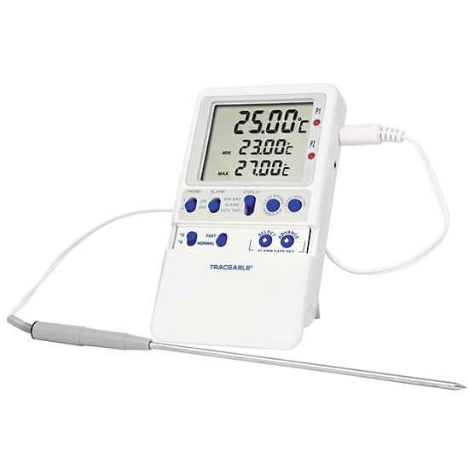
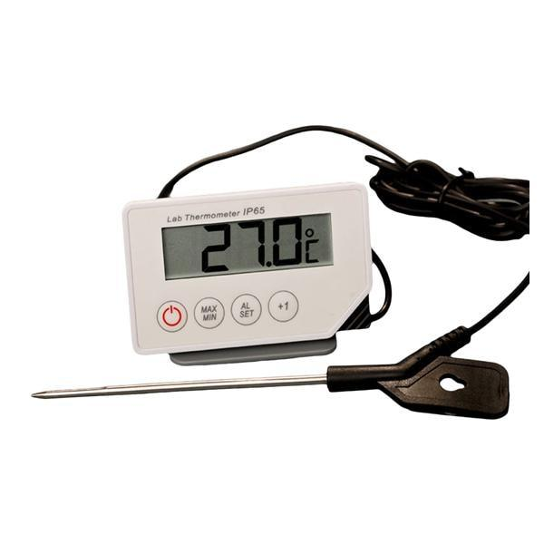
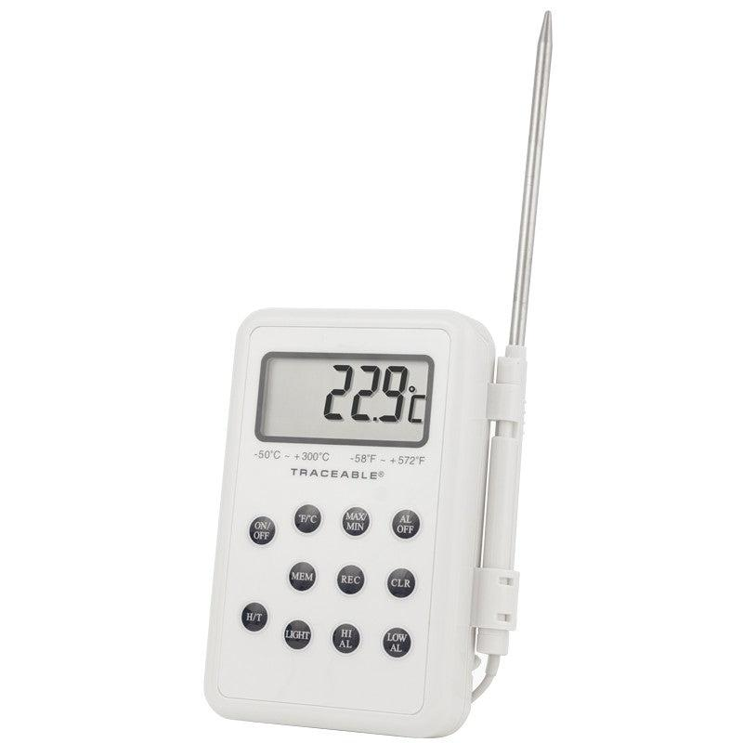
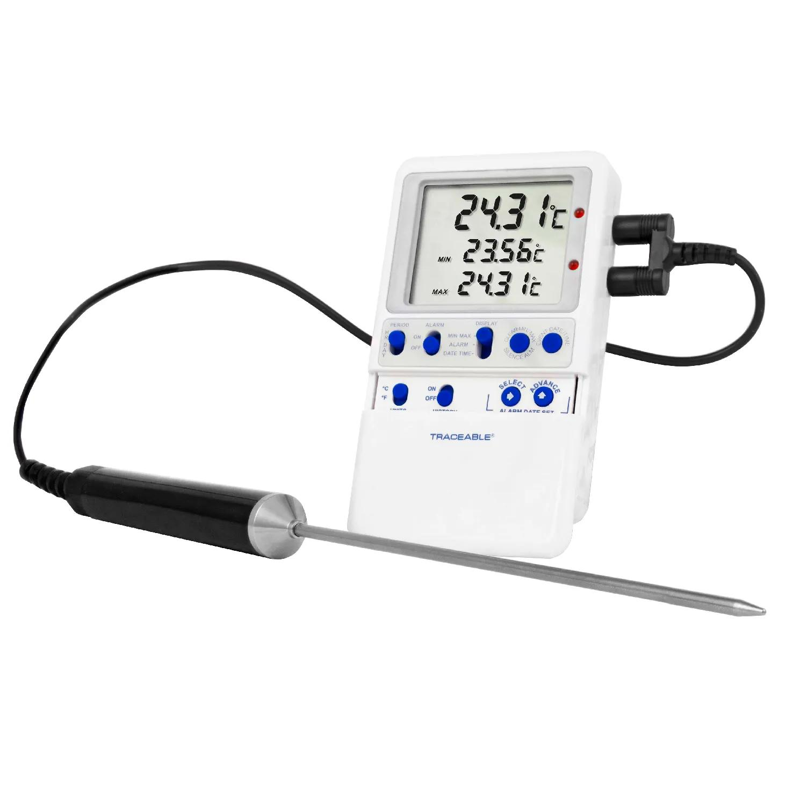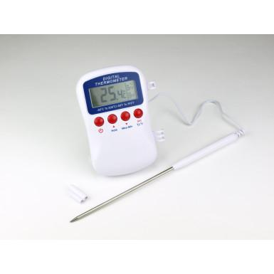
Description
Used for scientific measurements in laboratories.
Features
- High accuracy
- External probe
- Wide temperature range
Applications
- Chemistry
- Biology
- Physics
- Research

3. Food Digital Thermometer
# Source: AI Source: Provided by: [Data Path: Persons Table -> ID Column: 1, Name_En Column: Motasem Essam] -> From: [ChatGPT] on [7/17/2026]
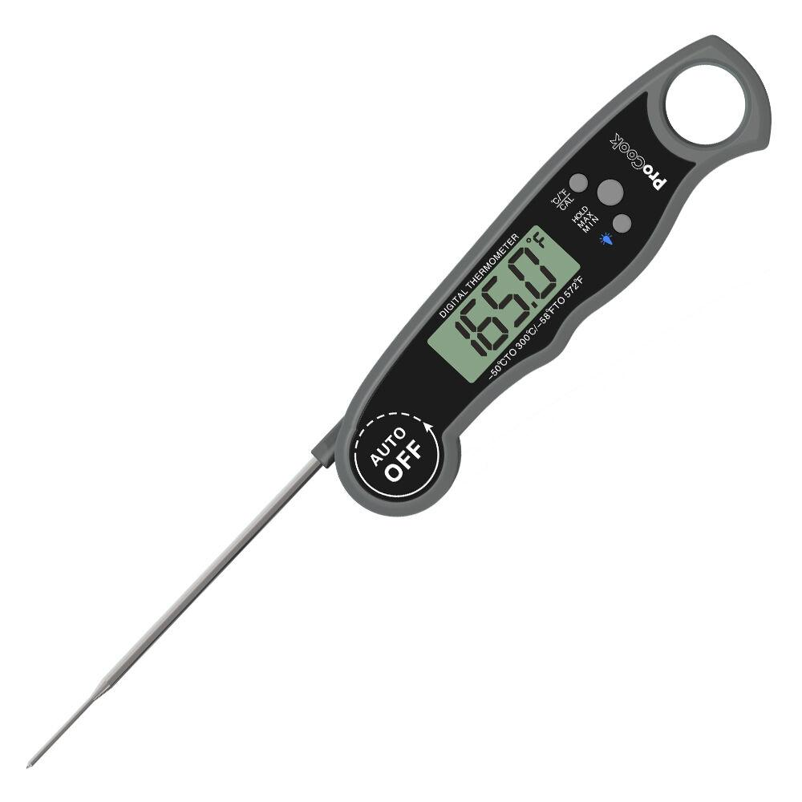
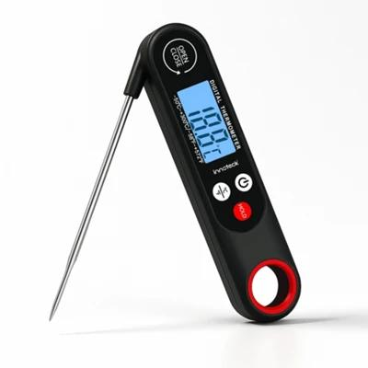
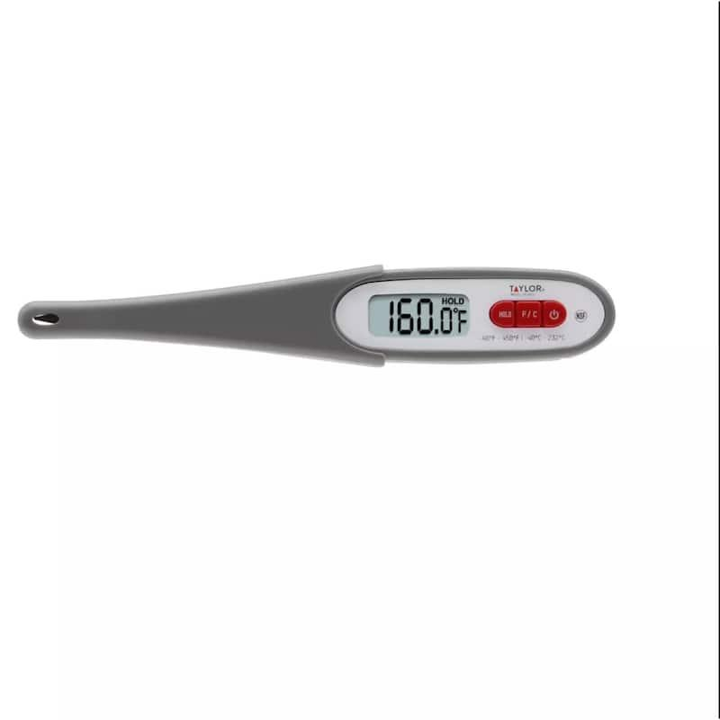
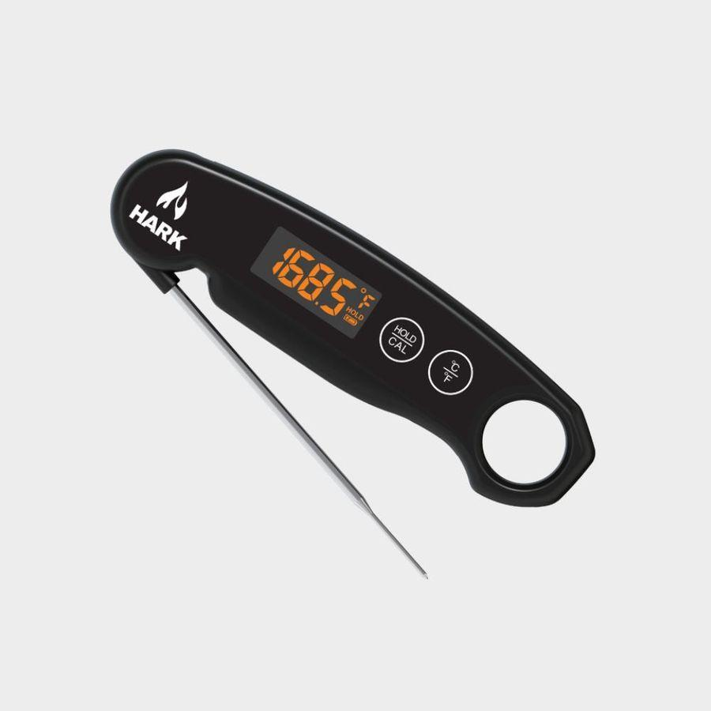
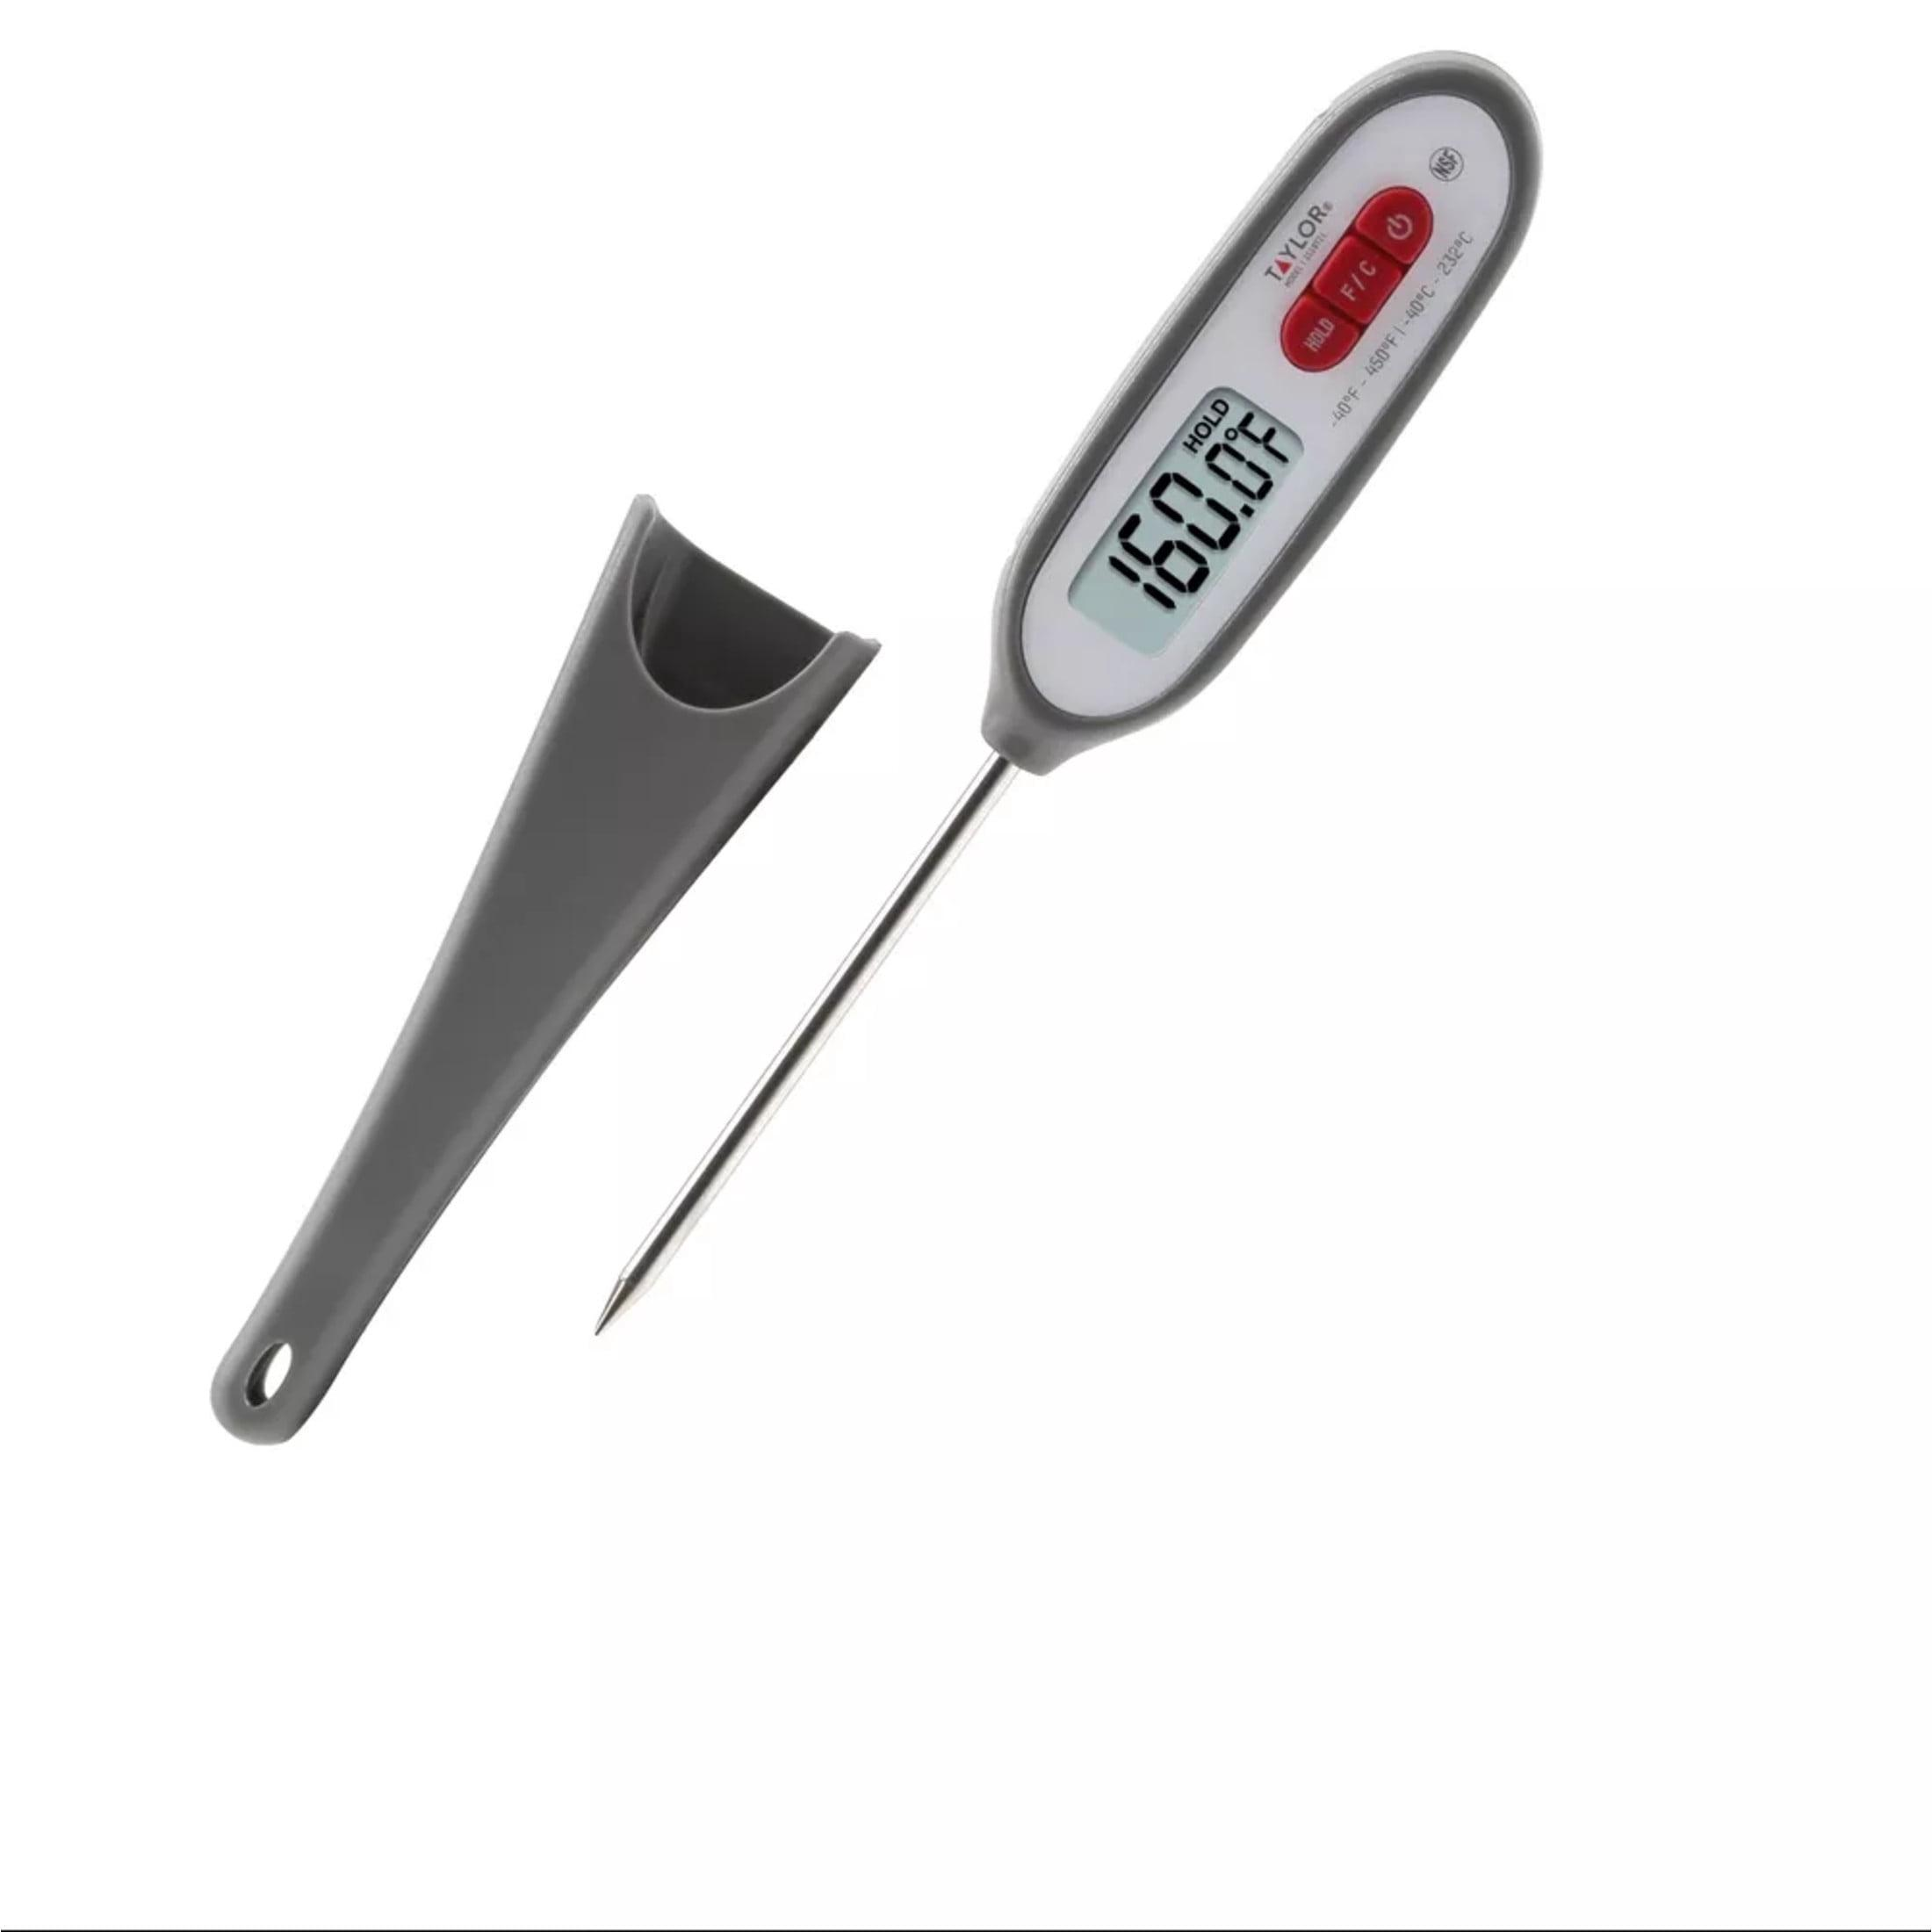
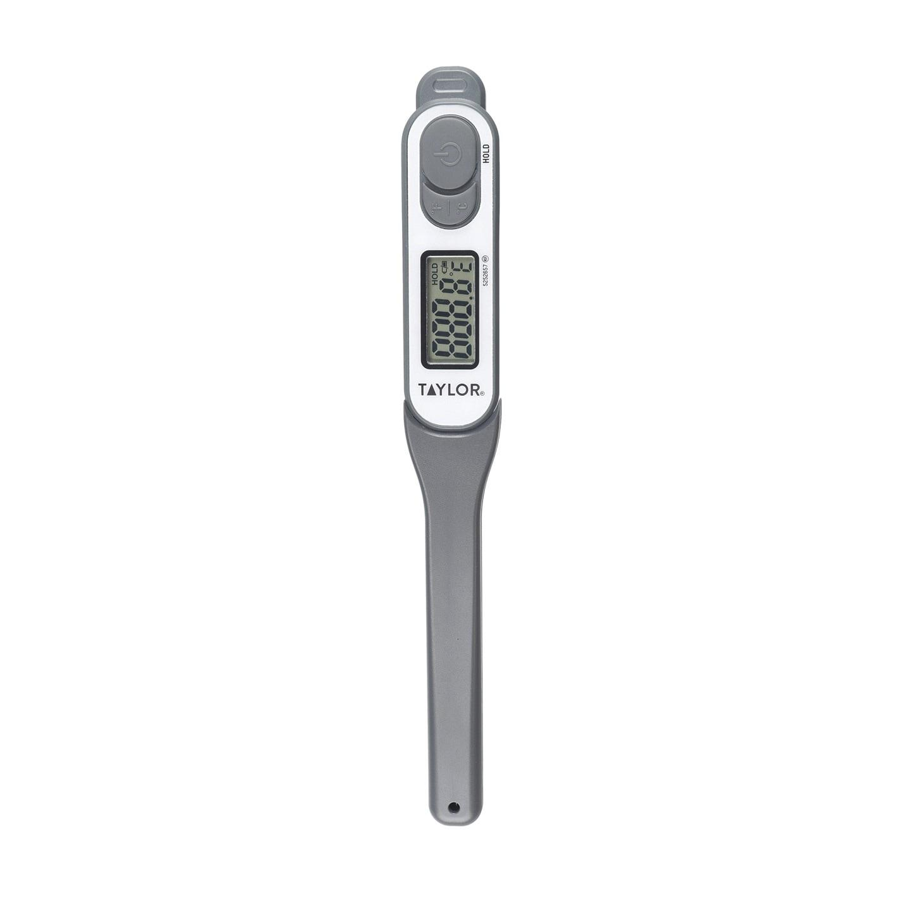
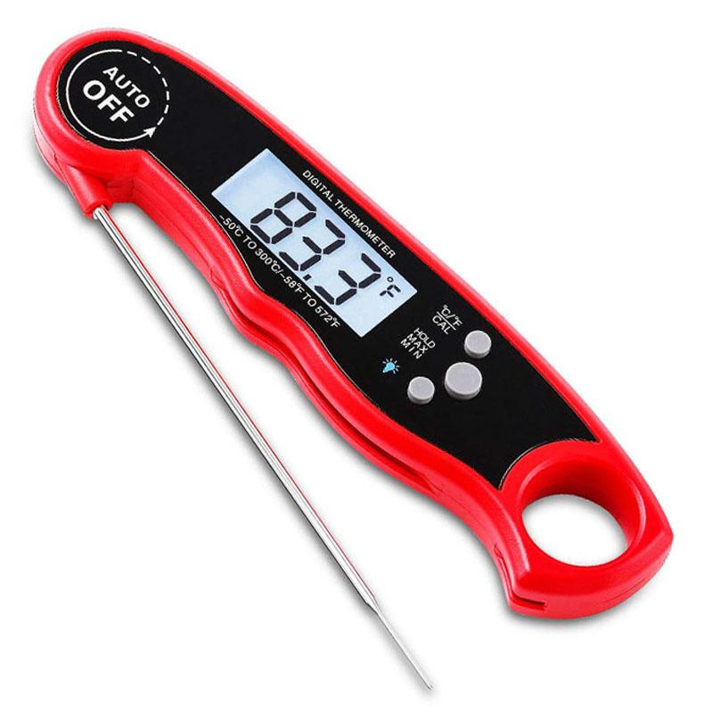
Description
Used to measure food temperatures during cooking and storage.
Applications
- Cooking
- Baking
- Restaurants
- Food safety

4. Industrial Digital Thermometer
# Source: AI Source: Provided by: [Data Path: Persons Table -> ID Column: 1, Name_En Column: Motasem Essam] -> From: [ChatGPT] on [7/17/2026]
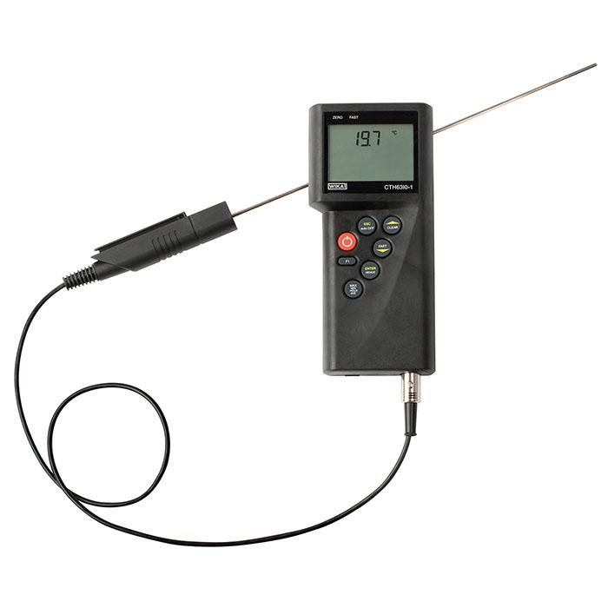
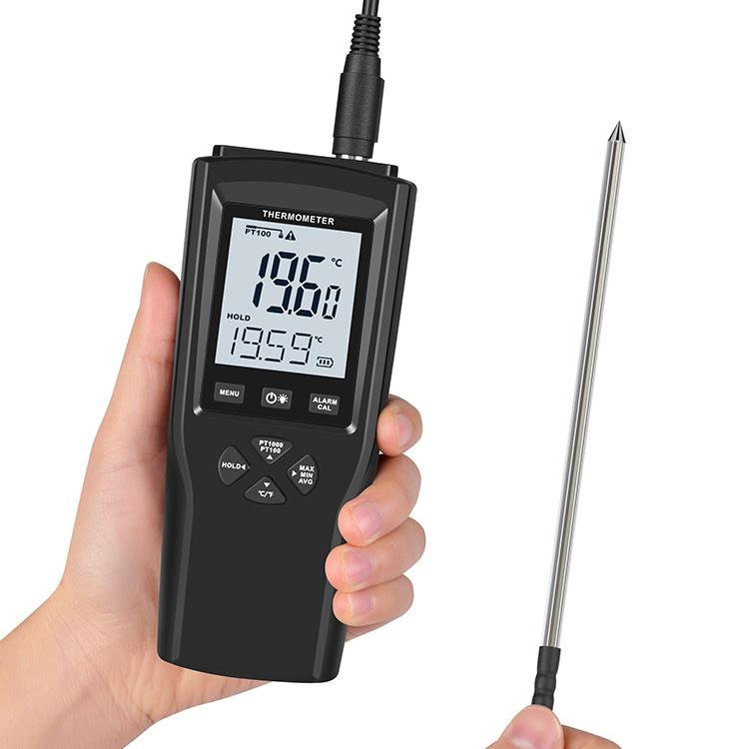
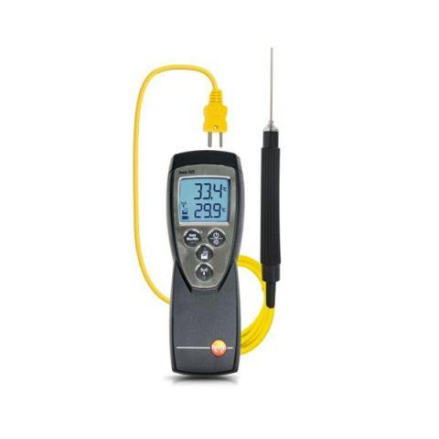
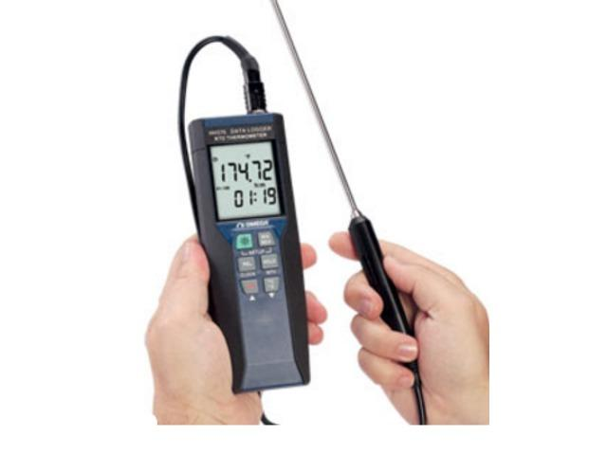
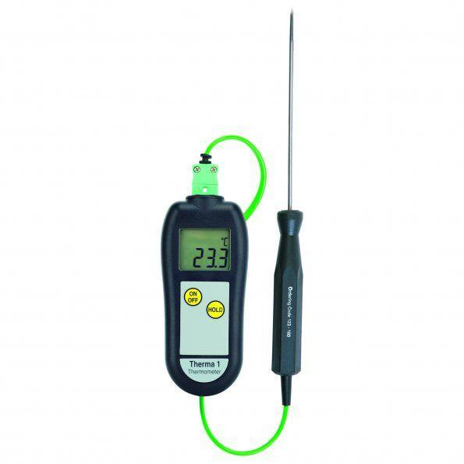
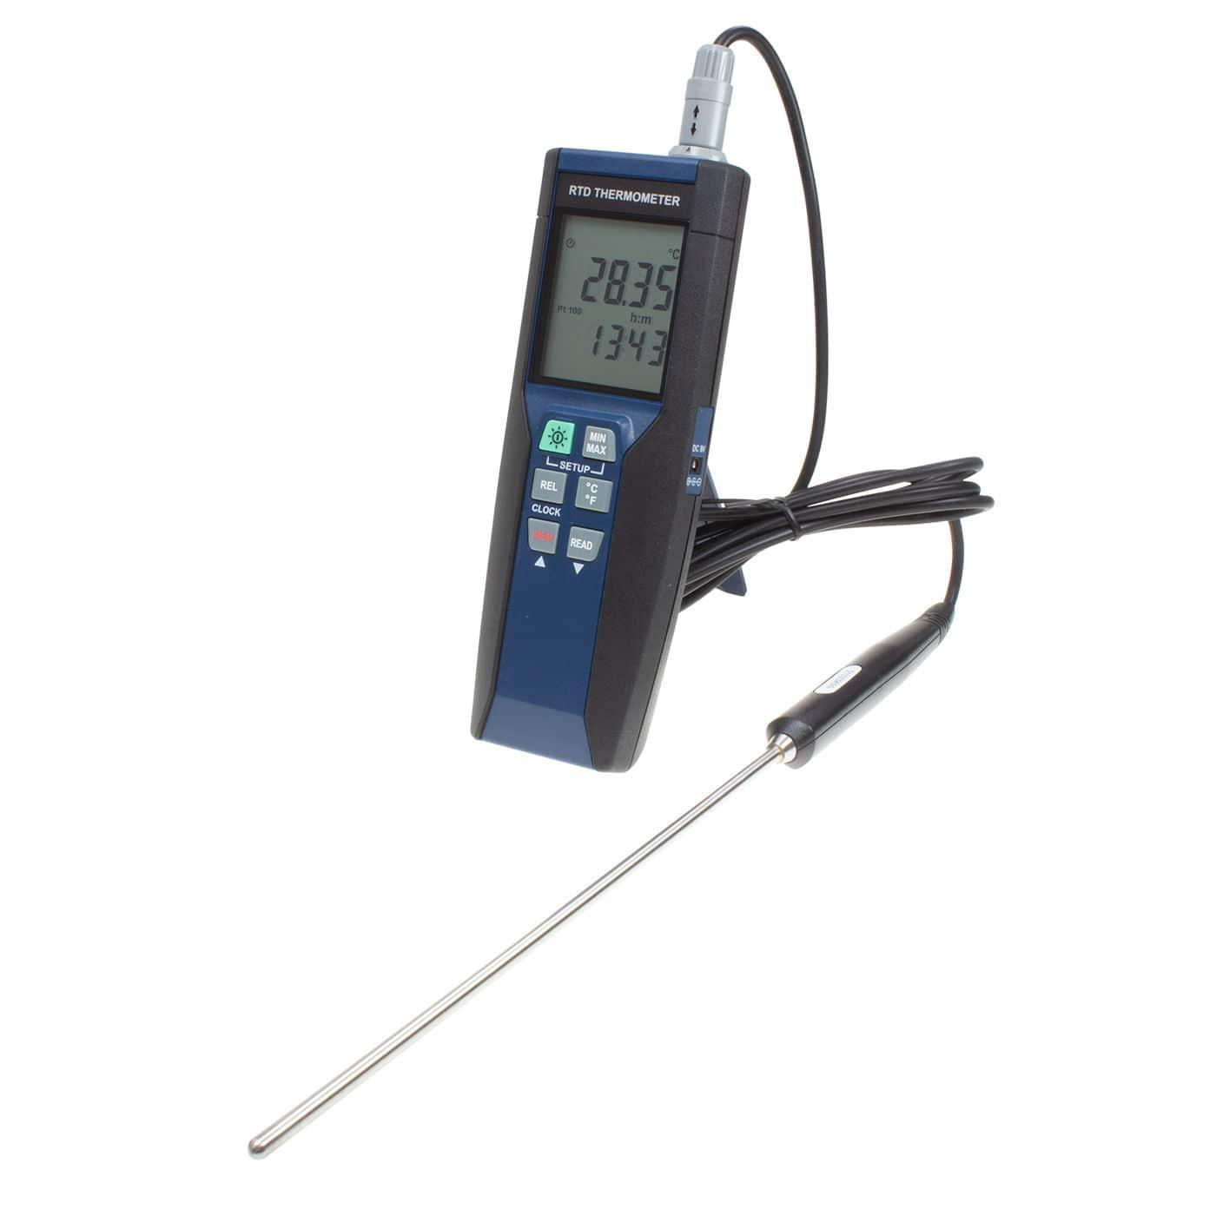
Description
Designed for industrial process monitoring.
Applications
- Manufacturing
- HVAC
- Chemical processing
- Industrial maintenance

5. Waterproof Digital Thermometer
# Source: AI Source: Provided by: [Data Path: Persons Table -> ID Column: 1, Name_En Column: Motasem Essam] -> From: [ChatGPT] on [7/17/2026]
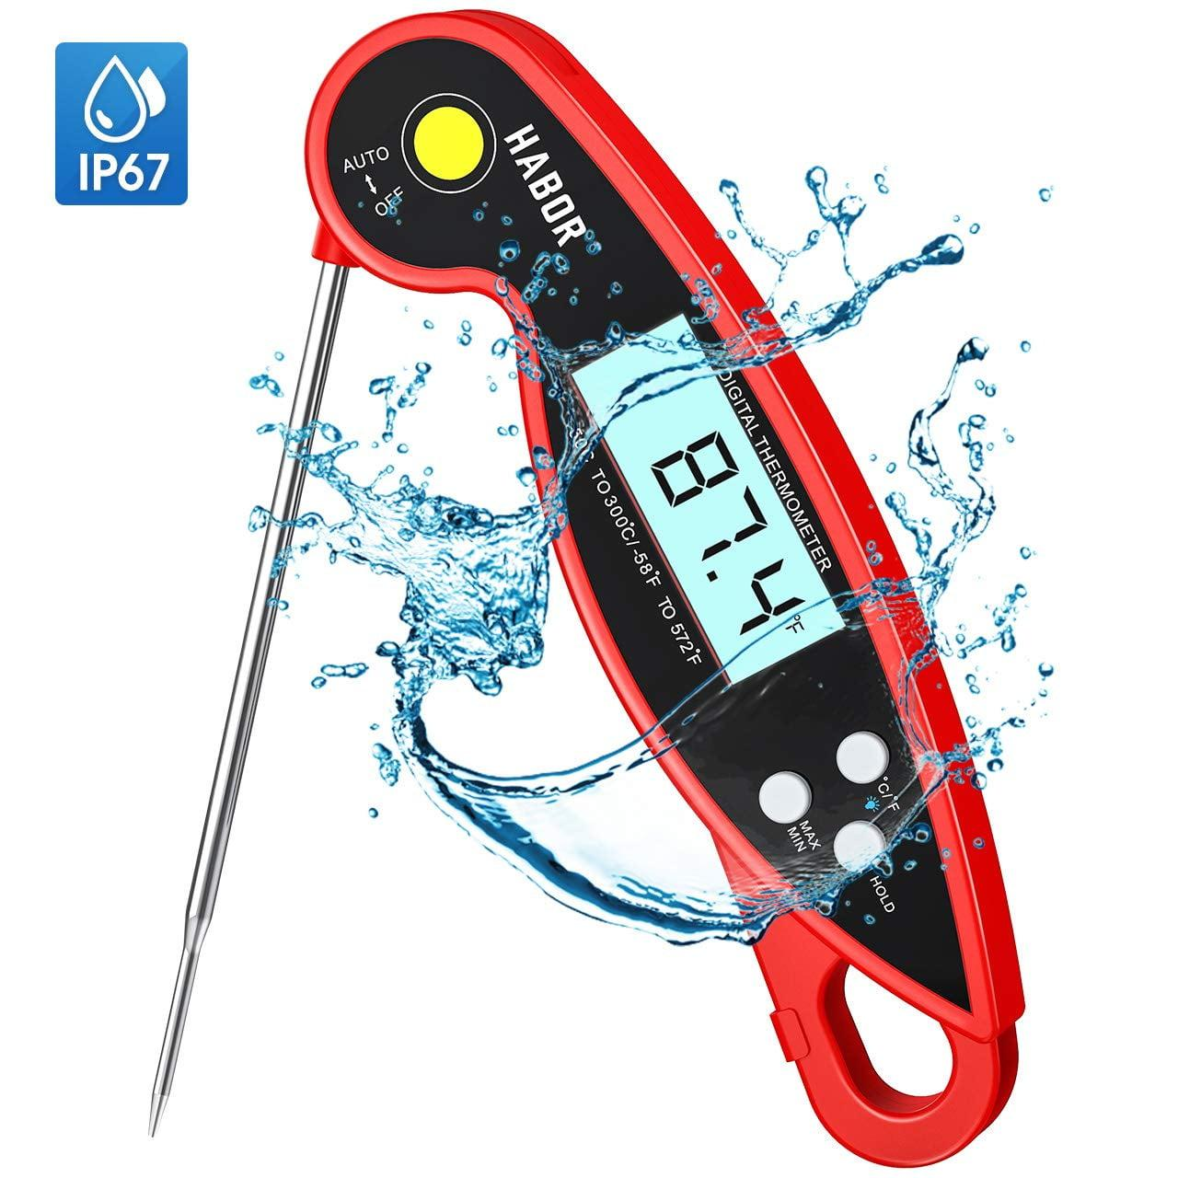
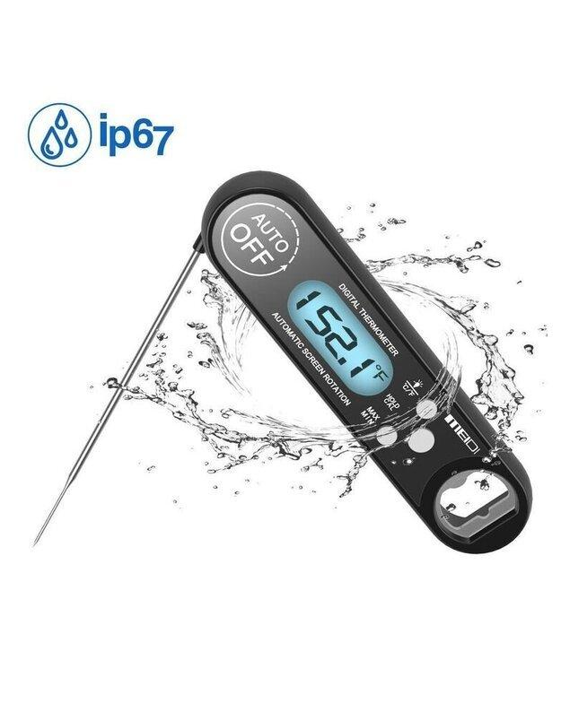
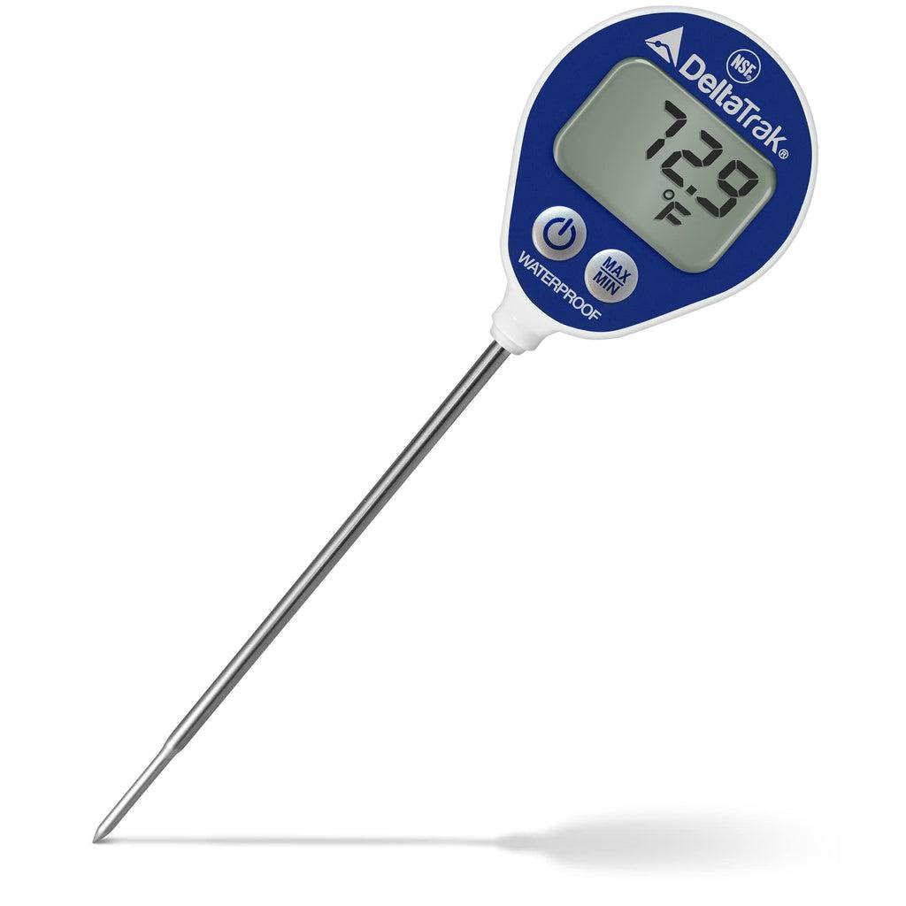


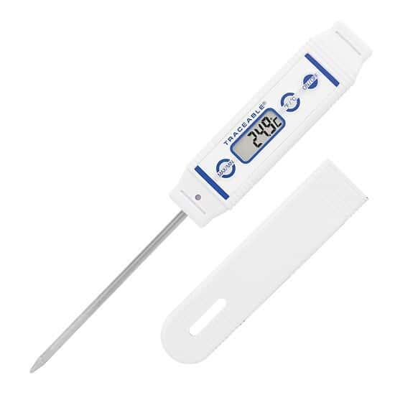
Description: Digital thermometer sealed against water and moisture, suitable for wet environments.
Applications:
- Food industry
- Laboratories
- Aquaculture
- Outdoor measurements

6. Refrigerator / Freezer Digital Thermometer
# Source: AI Source: Provided by: [Data Path: Persons Table -> ID Column: 1, Name_En Column: Motasem Essam] -> From: [ChatGPT] on [7/17/2026]
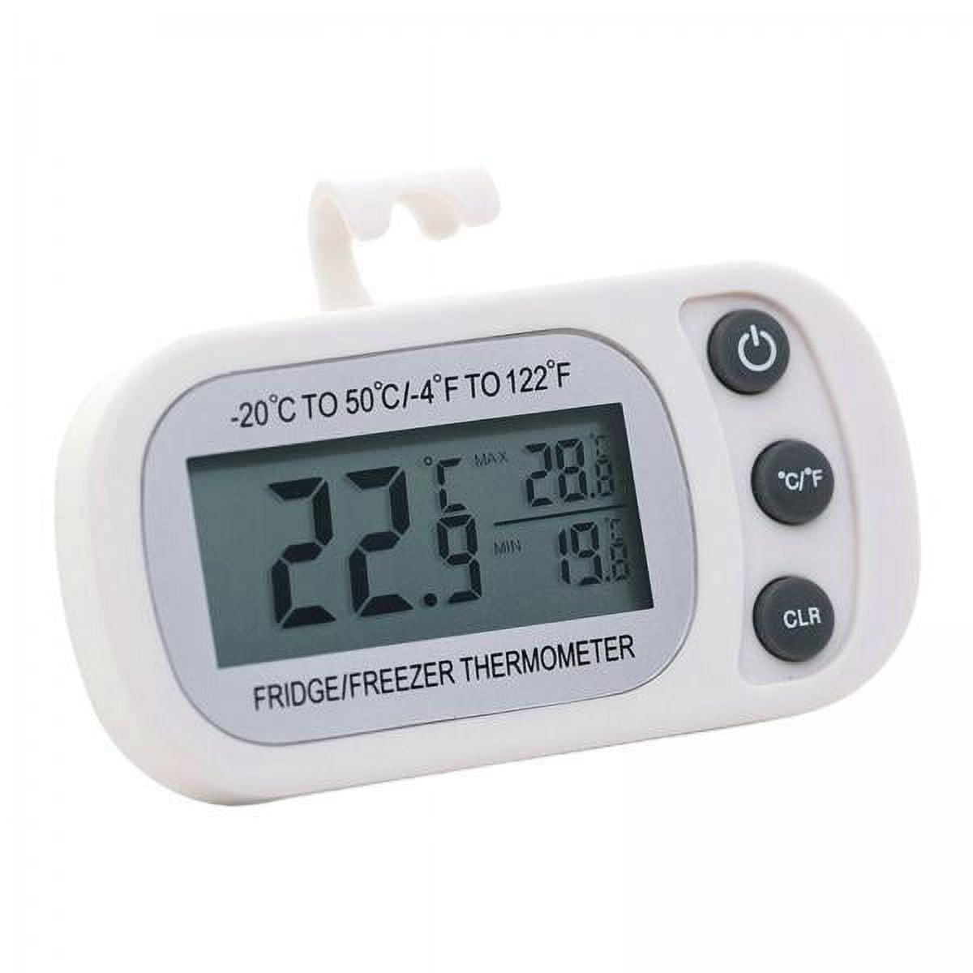
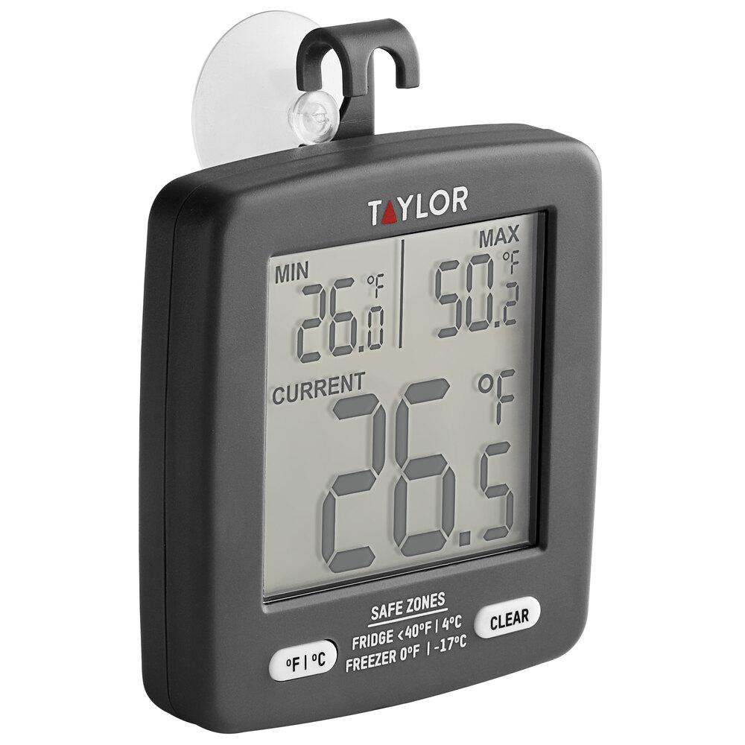
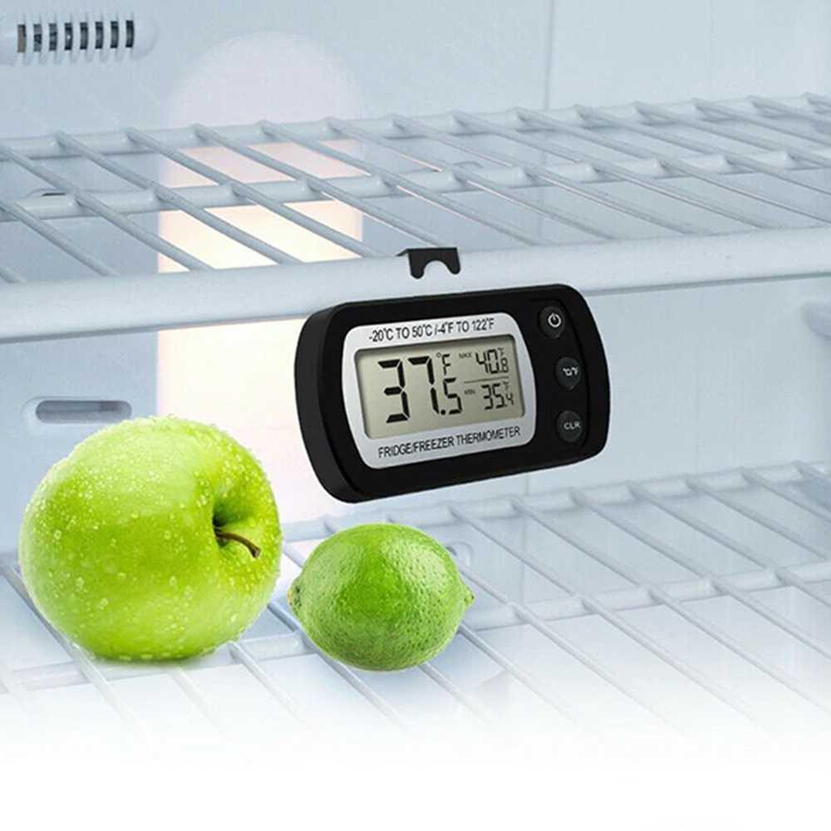
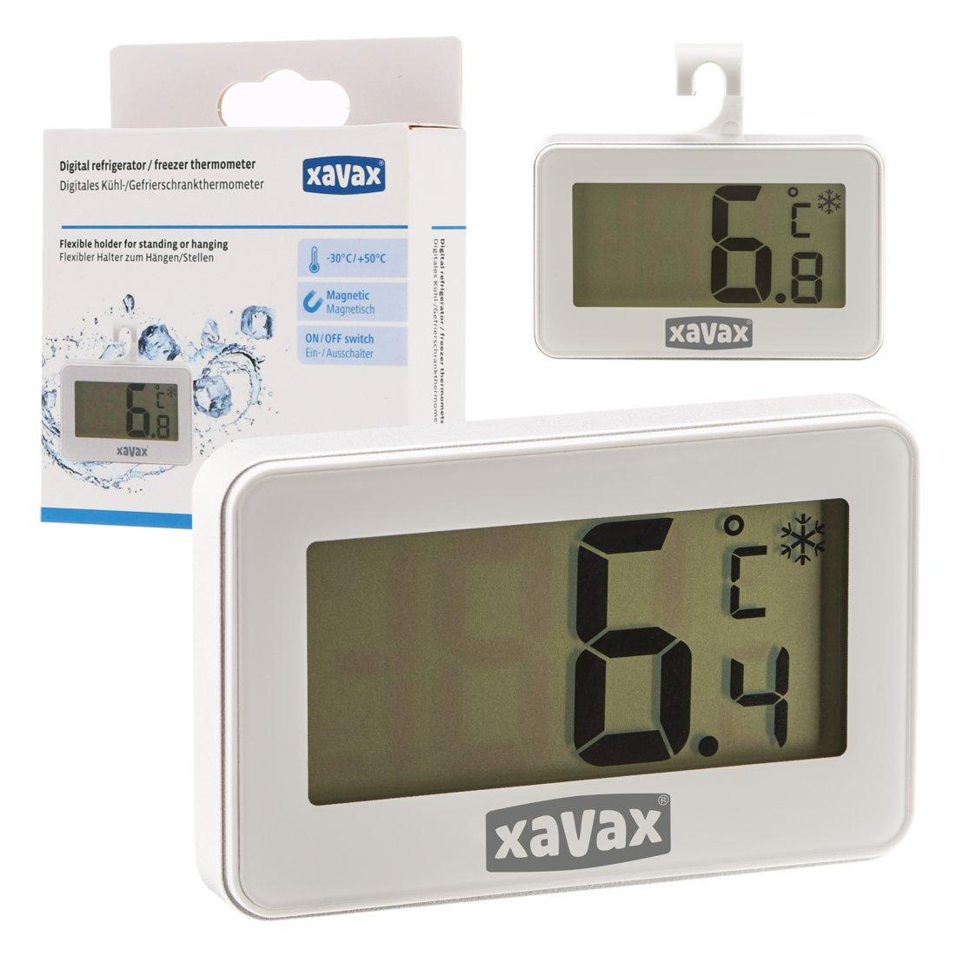
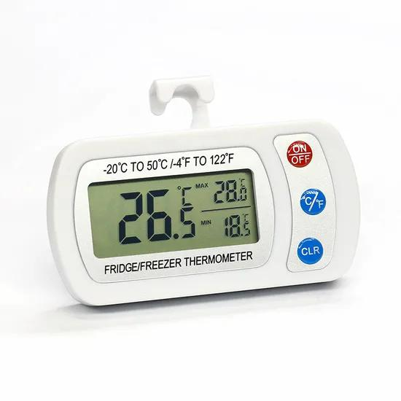
Description: Designed to continuously monitor refrigerator and freezer temperatures.
Applications:
- Refrigerators
- Freezers
- Cold storage
- Medical vaccine storage

7. Digital Thermometer with Data Logger
# Source: AI Source: Provided by: [Data Path: Persons Table -> ID Column: 1, Name_En Column: Motasem Essam] -> From: [ChatGPT] on [7/17/2026]
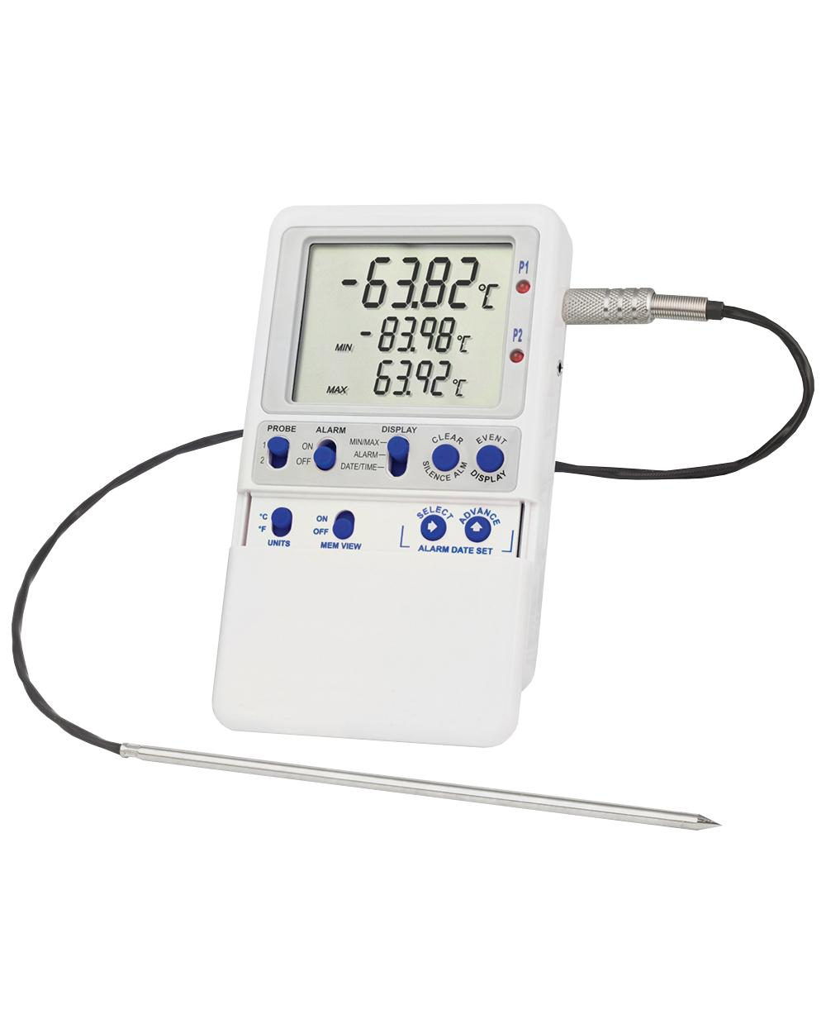
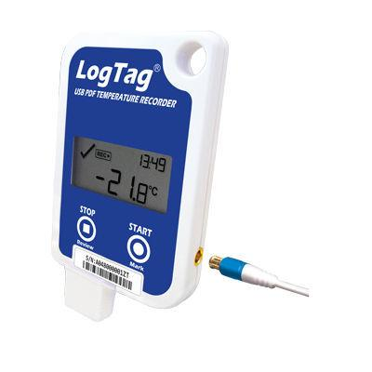
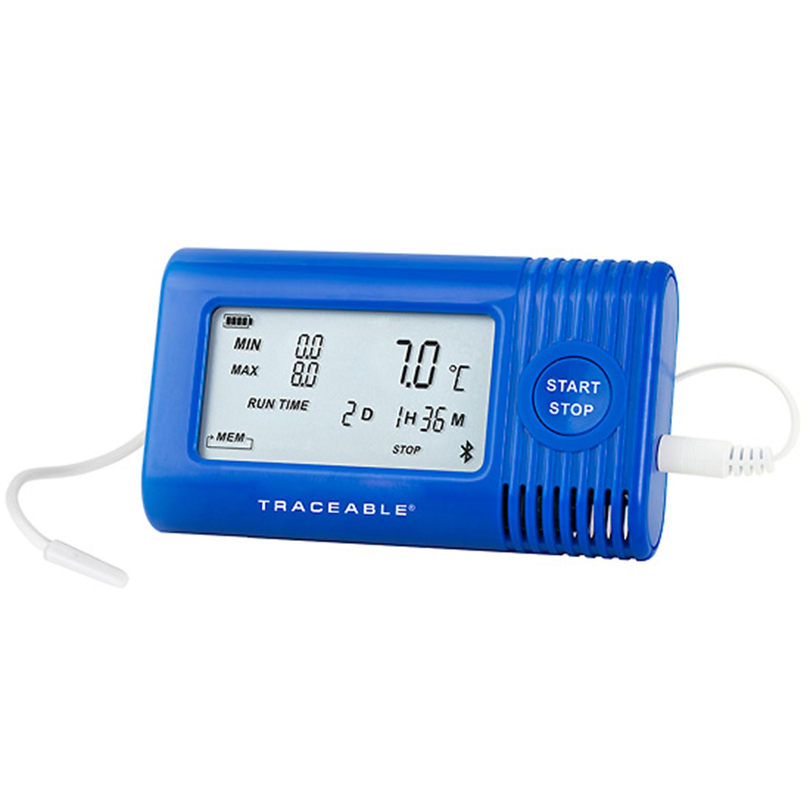
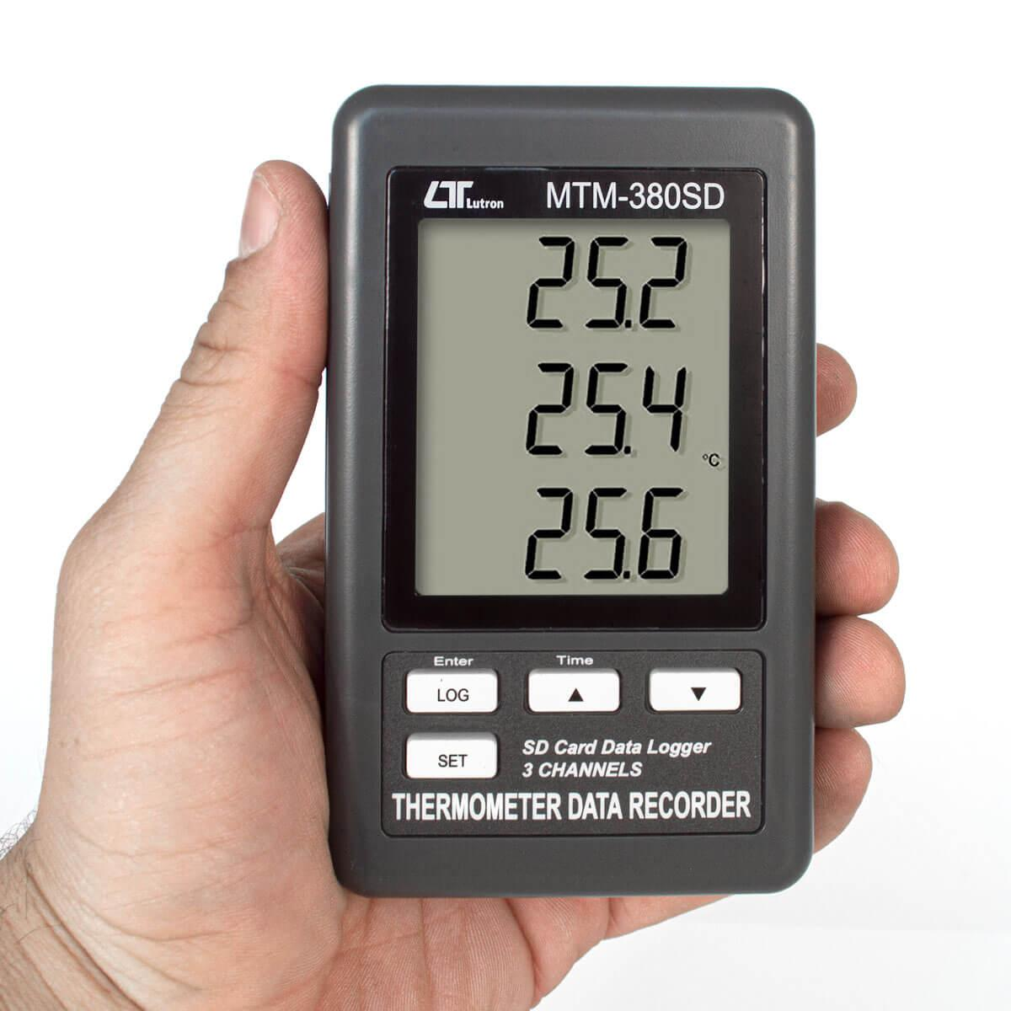
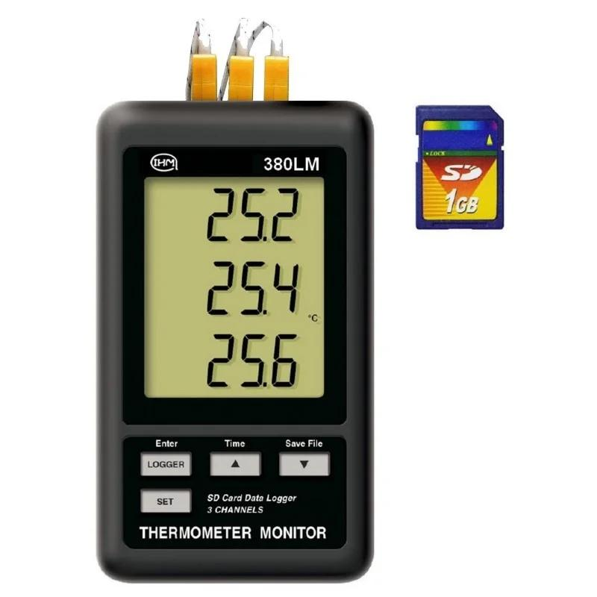
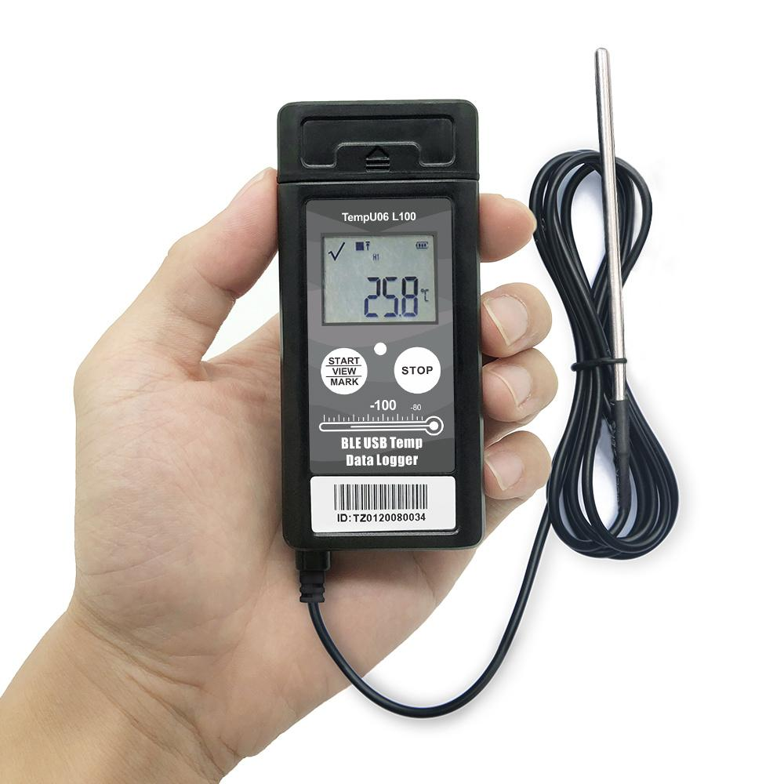
Description: Records temperature measurements over time for later analysis.
Applications:
- Scientific research
- Environmental monitoring
- Pharmaceutical storage
- Quality control

8. Infrared Digital Thermometer (Non-Contact)
# Source: AI Source: Provided by: [Data Path: Persons Table -> ID Column: 1, Name_En Column: Motasem Essam] -> From: [ChatGPT] on [7/17/2026]
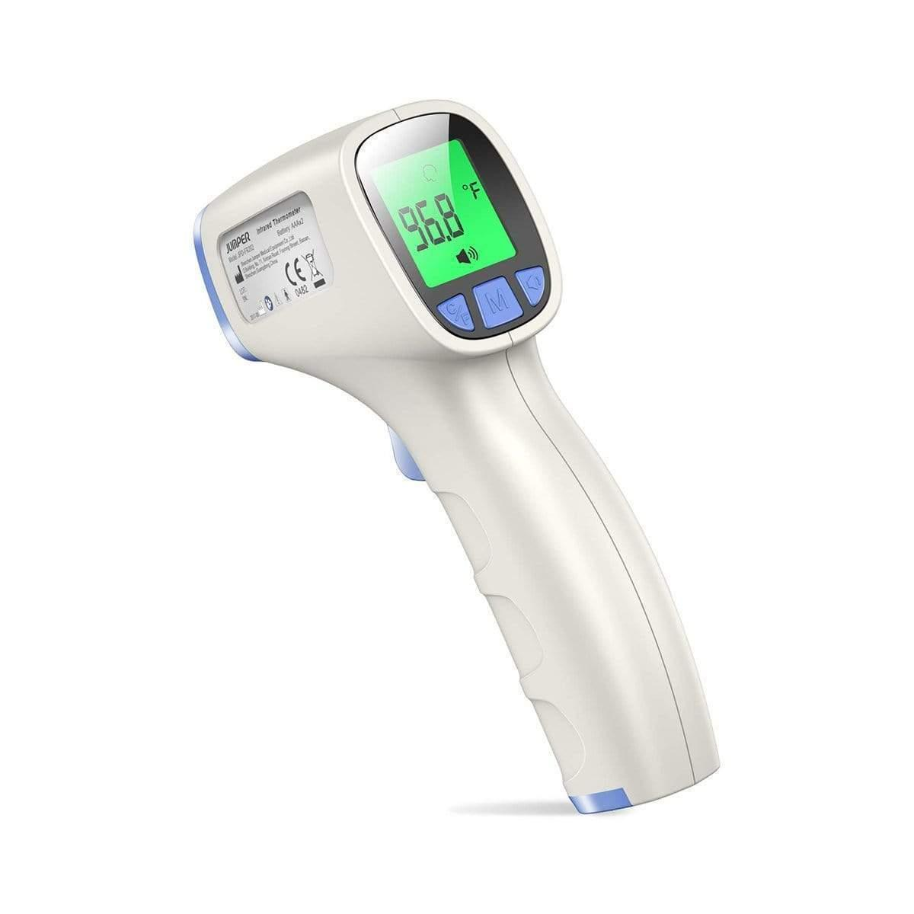
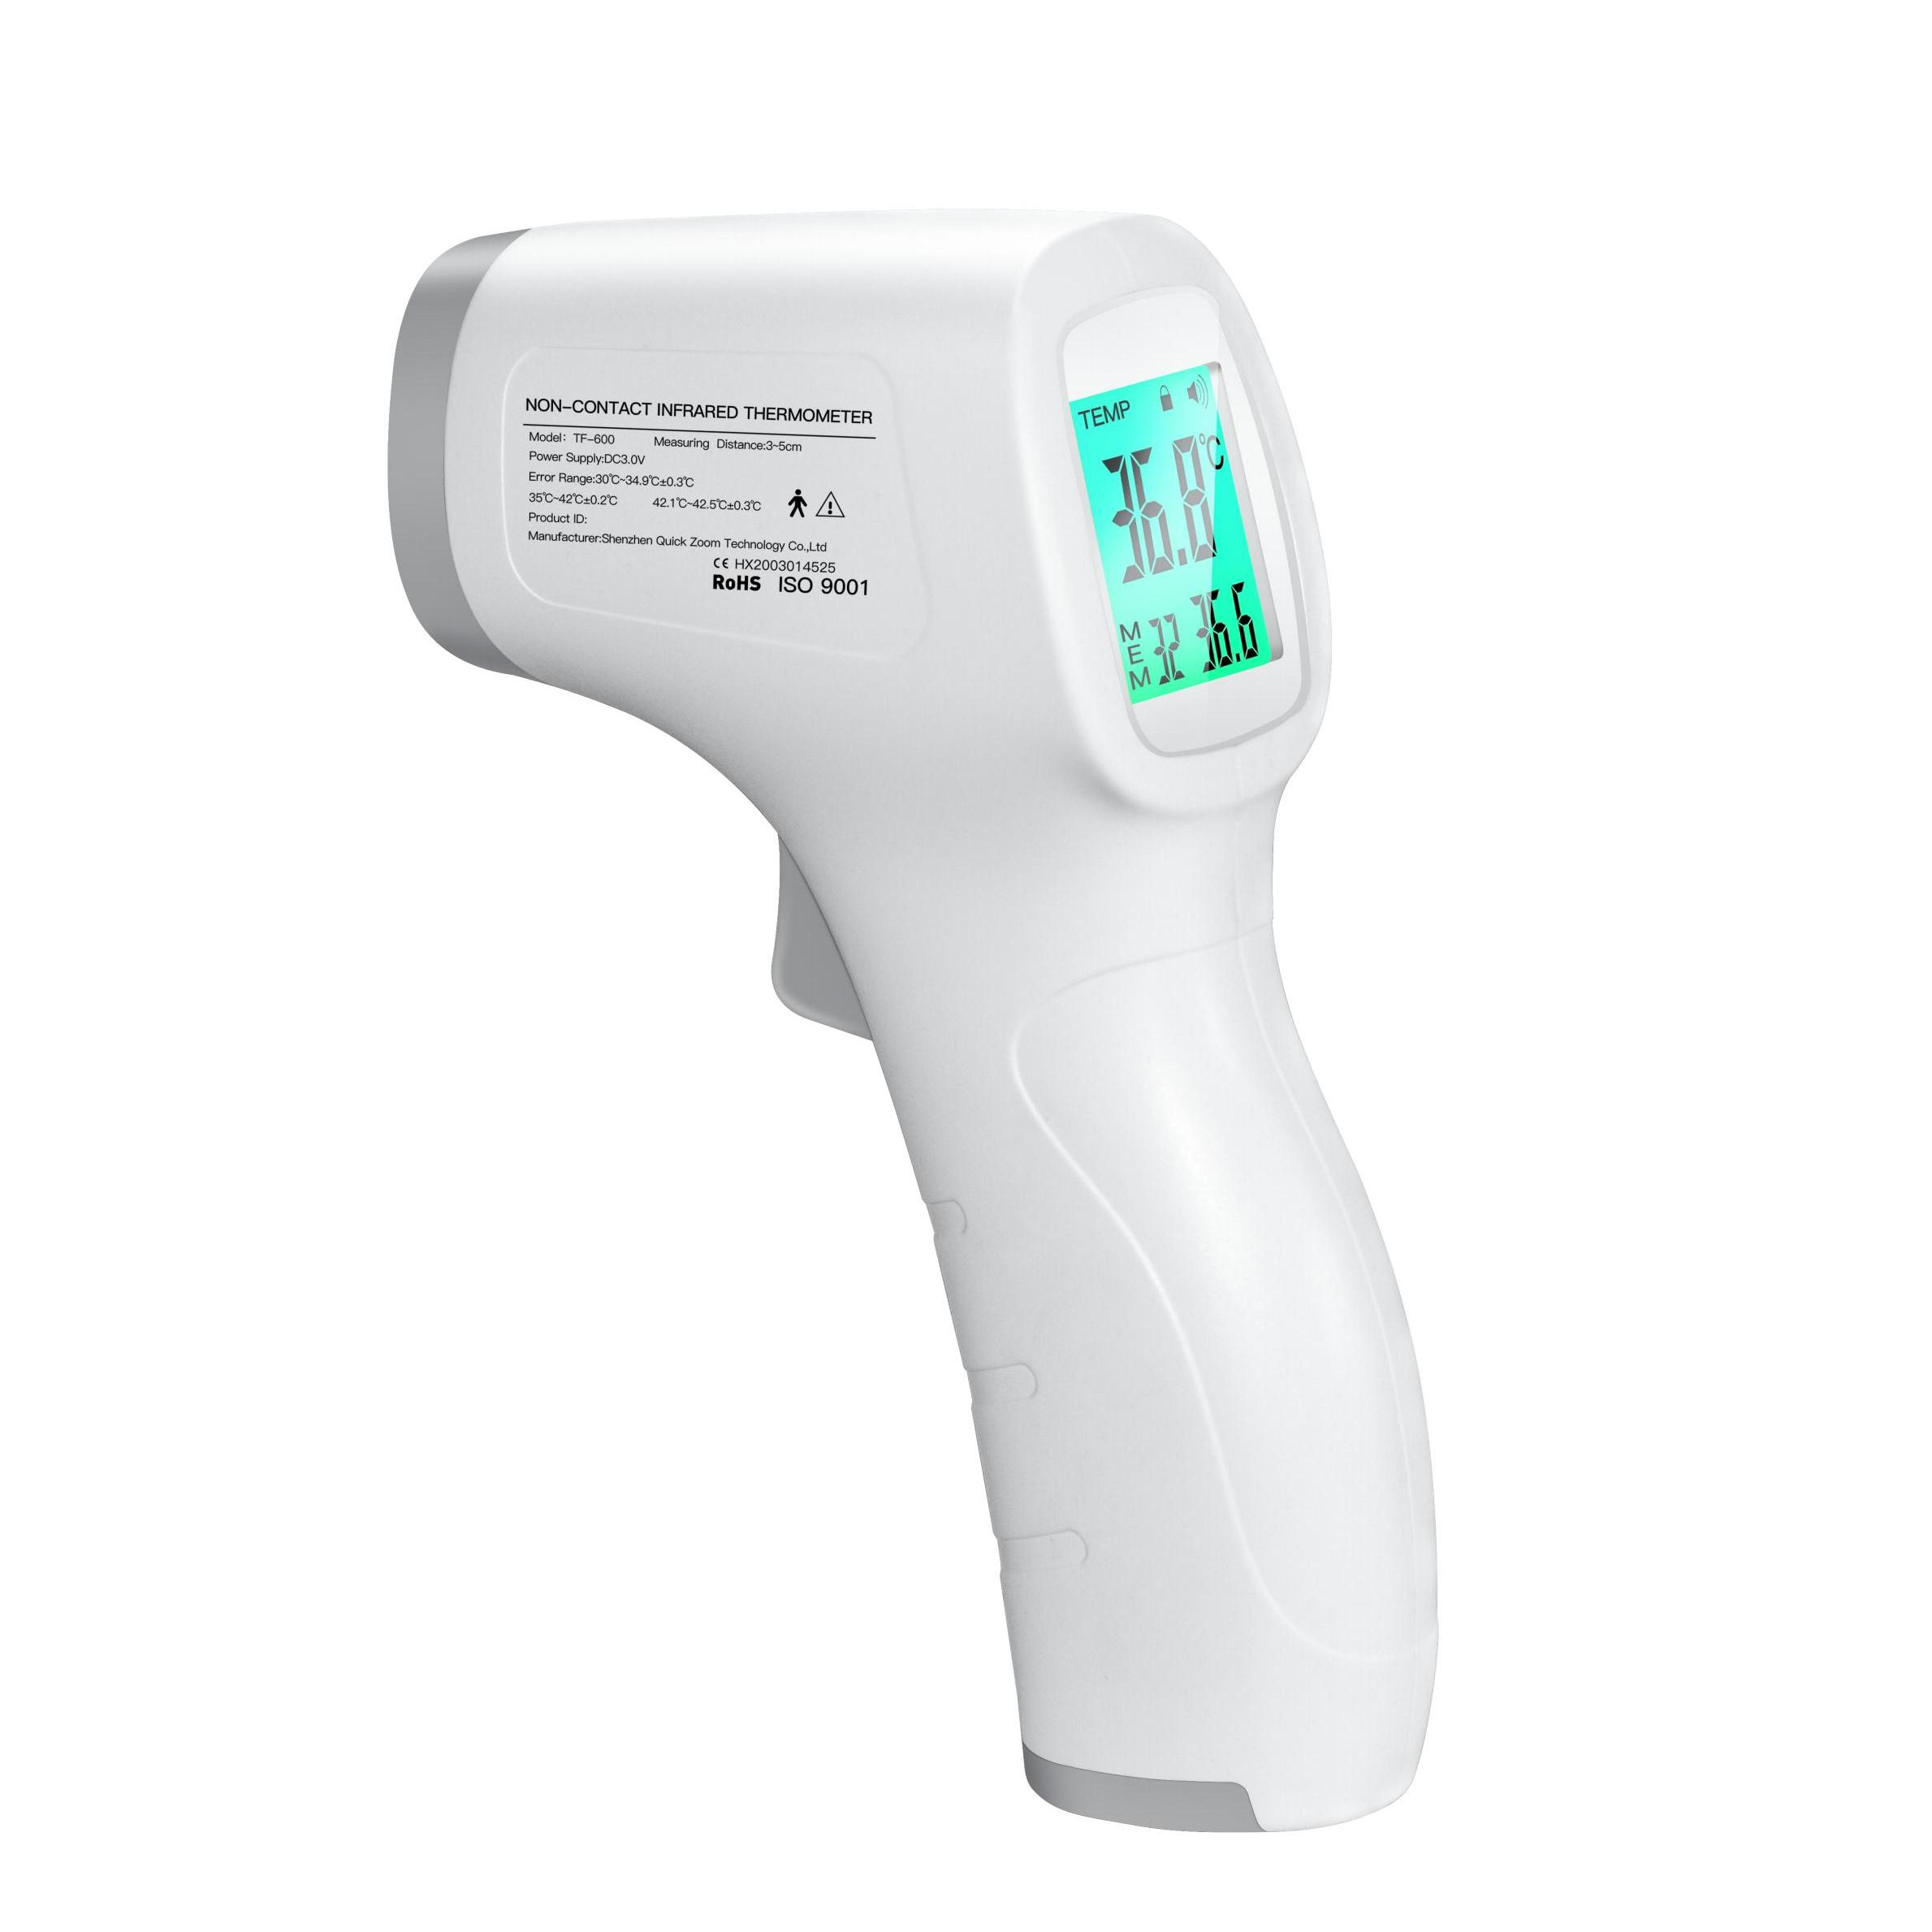
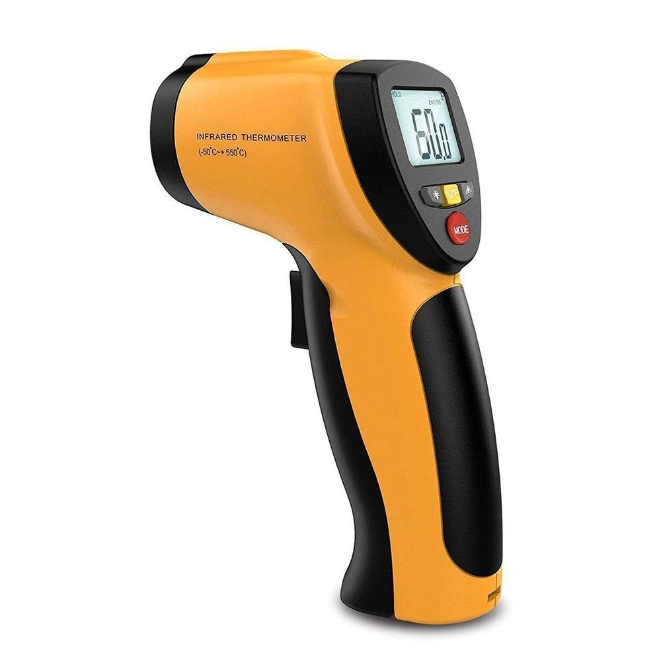
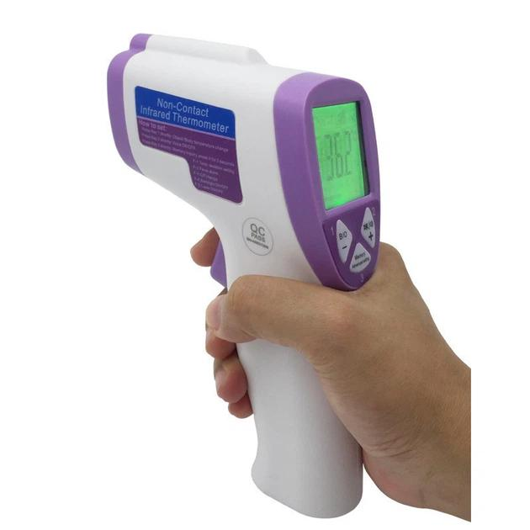
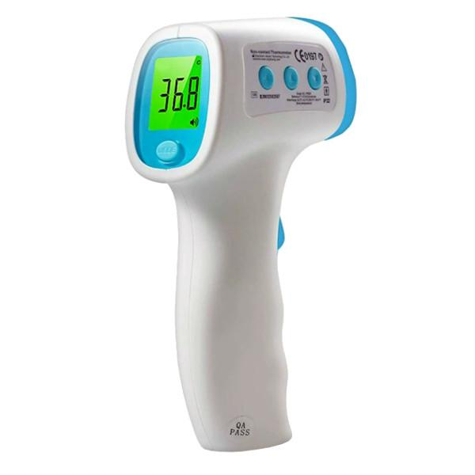
Description: Measures surface or body temperature without physical contact by detecting infrared radiation.
Applications:
- Medical screening
- Industrial inspection
- Electrical maintenance
- Food safety
Note: Although it is a digital thermometer, the infrared digital thermometer uses a completely different measurement principle (infrared radiation) than probe-based digital thermometers. It is often classified as a separate category of thermometer.

Common Temperature Sensors
# Source: AI Source: Provided by: [Data Path: Persons Table -> ID Column: 1, Name_En Column: Motasem Essam] -> From: [ChatGPT] on [7/17/2026]
Digital thermometers commonly use:
- Thermistor
- RTD (Resistance Temperature Detector)
- Thermocouple
- Semiconductor sensor

Measuring Units
# Source: AI Source: Provided by: [Data Path: Persons Table -> ID Column: 1, Name_En Column: Motasem Essam] -> From: [ChatGPT] on [7/17/2026]
Digital thermometers commonly display:
- Degrees Celsius (°C)
- Degrees Fahrenheit (°F)
Some advanced models may also support:
- Kelvin (K)

Measuring Range
# Source: AI Source: Provided by: [Data Path: Persons Table -> ID Column: 1, Name_En Column: Motasem Essam] -> From: [ChatGPT] on [7/17/2026]
Typical ranges:
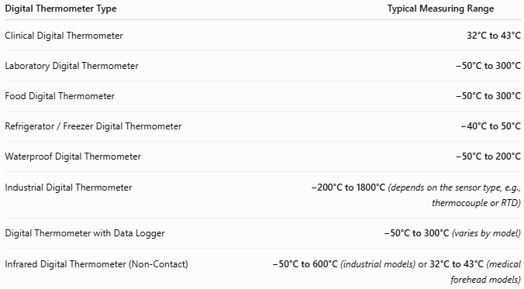
Digital Thermometer Type | Typical Measuring Range
Clinical Digital Thermometer | 32°C to 43°C
Laboratory Digital Thermometer | −50°C to 300°C
Food Digital Thermometer | −50°C to 300°C
Refrigerator / Freezer Digital Thermometer | −40°C to 50°C
Waterproof Digital Thermometer | −50°C to 200°C
Industrial Digital Thermometer | −200°C to 1800°C (depends on the sensor type, e.g., thermocouple or RTD)
Digital Thermometer with Data Logger | −50°C to 300°C (varies by model)
Infrared Digital Thermometer (Non-Contact) | −50°C to 600°C (industrial models) or 32°C to 43°C (medical forehead models)

Resolution
# Source: AI Source: Provided by: [Data Path: Persons Table -> ID Column: 1, Name_En Column: Motasem Essam] -> From: [ChatGPT] on [7/17/2026]
Typical resolutions:
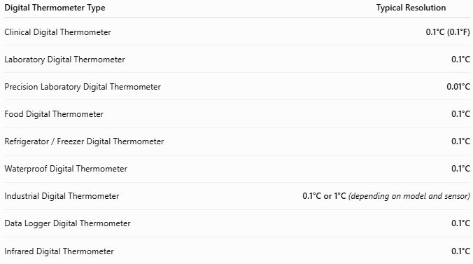
Digital Thermometer Type | Typical Resolution
Clinical Digital Thermometer | 0.1°C (0.1°F)
Laboratory Digital Thermometer | 0.1°C
Precision Laboratory Digital Thermometer | 0.01°C
Food Digital Thermometer | 0.1°C
Refrigerator / Freezer Digital Thermometer | 0.1°C
Waterproof Digital Thermometer | 0.1°C
Industrial Digital Thermometer | 0.1°C or 1°C (depending on model and sensor)
Data Logger Digital Thermometer | 0.1°C
Infrared Digital Thermometer | 0.1°C

Accuracy
# Source: AI Source: Provided by: [Data Path: Persons Table -> ID Column: 1, Name_En Column: Motasem Essam] -> From: [ChatGPT] on [7/17/2026]
Typical accuracy:
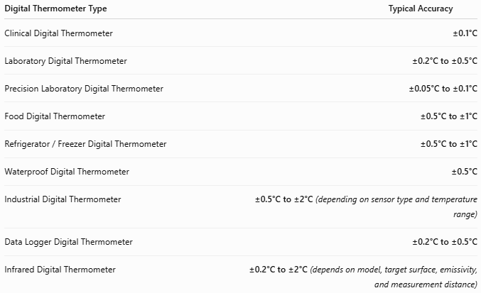
Digital Thermometer Type | Typical Accuracy
Clinical Digital Thermometer | ±0.1°C
Laboratory Digital Thermometer | ±0.2°C to ±0.5°C
Precision Laboratory Digital Thermometer | ±0.05°C to ±0.1°C
Food Digital Thermometer | ±0.5°C to ±1°C
Refrigerator / Freezer Digital Thermometer | ±0.5°C to ±1°C
Waterproof Digital Thermometer | ±0.5°C
Industrial Digital Thermometer | ±0.5°C to ±2°C (depending on sensor type and temperature range)
Data Logger Digital Thermometer | ±0.2°C to ±0.5°C
Infrared Digital Thermometer | ±0.2°C to ±2°C (depends on model, target surface, emissivity, and measurement distance)

How to Use a Digital Thermometer
# Source: AI Source: Provided by: [Data Path: Persons Table -> ID Column: 1, Name_En Column: Motasem Essam] -> From: [ChatGPT] on [7/17/2026]
- Turn the thermometer on.
- Select the desired unit (°C or °F) if applicable.
- Place the probe on or in the object being measured.
- Wait until the reading stabilizes or the completion signal sounds.
- Read the displayed temperature.
- Clean the probe after use if required.

Example
The display reads:
36.8°C
Measured temperature:
36.8°C

Applications
# Source: AI Source: Provided by: [Data Path: Persons Table -> ID Column: 1, Name_En Column: Motasem Essam] -> From: [ChatGPT] on [7/17/2026]
Digital thermometers are used in:
- Hospitals
- Clinics
- Medical laboratories
- Chemistry laboratories
- Biology laboratories
- Food processing
- Restaurants
- Refrigeration
- Environmental monitoring
- Industrial quality control

Advantages
# Source: AI Source: Provided by: [Data Path: Persons Table -> ID Column: 1, Name_En Column: Motasem Essam] -> From: [ChatGPT] on [7/17/2026]
A digital thermometer:
- Provides fast measurements.
- Offers high accuracy.
- Has an easy-to-read display.
- Contains no mercury.
- Can automatically switch off to save battery power (many models).
- Often stores previous readings (depending on the model).

Limitations
# Source: AI Source: Provided by: [Data Path: Persons Table -> ID Column: 1, Name_En Column: Motasem Essam] -> From: [ChatGPT] on [7/17/2026]
A digital thermometer:
- Requires batteries or another power source.
- Electronic components may fail if exposed to moisture beyond their rating.
- Needs periodic calibration in professional applications.
- Very inexpensive models may have lower accuracy.

Sources of Error
# Source: AI Source: Provided by: [Data Path: Persons Table -> ID Column: 1, Name_En Column: Motasem Essam] -> From: [ChatGPT] on [7/17/2026]
Instrument Errors
- Sensor calibration drift
- Low battery voltage
- Damaged probe
- Electronic malfunction

User Errors
- Incorrect probe placement
- Removing the probe before the reading stabilizes
- Failing to clean the probe between measurements
- Using the wrong measurement mode

Environmental Errors
- Strong electromagnetic interference
- Rapid temperature changes
- Poor thermal contact between the probe and the object

Comparison with Other Temperature Measuring Instruments
# Source: AI Source: Provided by: [Data Path: Persons Table -> ID Column: 1, Name_En Column: Motasem Essam] -> From: [ChatGPT] on [7/17/2026]
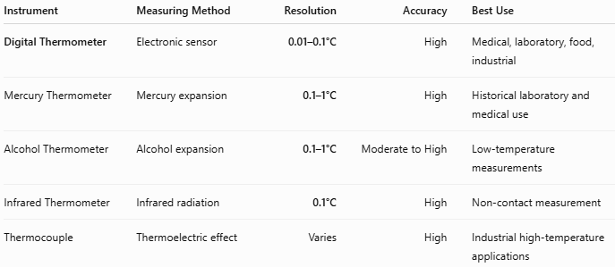
Instrument | Measuring Method | Resolution | Accuracy | Best Use
Digital Thermometer | Electronic sensor | 0.01–0.1°C | High | Medical, laboratory, food, industrial
Mercury Thermometer | Mercury expansion | 0.1–1°C | High | Historical laboratory and medical use
Alcohol Thermometer | Alcohol expansion | 0.1–1°C | Moderate to High | Low-temperature measurements
Infrared Thermometer | Infrared radiation | 0.1°C | High | Non-contact measurement
Thermocouple | Thermoelectric effect | Varies | High | Industrial high-temperature applications

Care and Maintenance
# Source: AI Source: Provided by: [Data Path: Persons Table -> ID Column: 1, Name_En Column: Motasem Essam] -> From: [ChatGPT] on [7/17/2026]
To maintain accuracy:
- Replace batteries when needed.
- Keep the probe clean.
- Avoid dropping the thermometer.
- Store in a protective case.
- Calibrate periodically if used in regulated laboratory or industrial environments.
- Follow the manufacturer's cleaning and storage instructions.

Common Mistakes
# Source: AI Source: Provided by: [Data Path: Persons Table -> ID Column: 1, Name_En Column: Motasem Essam] -> From: [ChatGPT] on [7/17/2026]
- Measuring before the reading stabilizes.
- Using a damaged probe.
- Ignoring low-battery warnings.
- Measuring without proper probe contact.
- Forgetting to disinfect clinical thermometers between users.

Key Points
# Source: AI Source: Provided by: [Data Path: Persons Table -> ID Column: 1, Name_En Column: Motasem Essam] -> From: [ChatGPT] on [7/17/2026]
- A Digital Thermometer measures temperature electronically using a sensor.
- Common types:
  - Clinical Digital Thermometer
  - Laboratory Digital Thermometer
  - Food Digital Thermometer
  - Industrial Digital Thermometer
- Common units:
  - °C
  - °F
- Typical accuracy:
  - ±0.1°C (clinical models)
- It is now the most widely used temperature-measuring instrument in medicine, laboratories, food safety, and industry because of its speed, precision, and safety.

Conclusion
# Source: AI Source: Provided by: [Data Path: Persons Table -> ID Column: 1, Name_En Column: Motasem Essam] -> From: [ChatGPT] on [7/17/2026]
A Digital Thermometer is a modern electronic temperature-measuring instrument that combines high accuracy, rapid response, and ease of use. By converting the output of an electronic temperature sensor into a digital reading, it eliminates many of the limitations associated with traditional liquid-in-glass thermometers. Its versatility, safety, and reliability make it the preferred choice for medical diagnosis, scientific research, food safety, environmental monitoring, and industrial process control, making it one of the most important temperature-measuring tools in contemporary practice.

